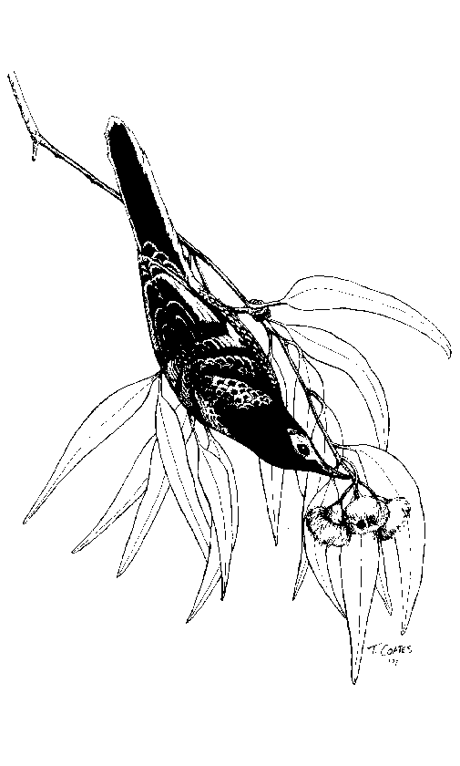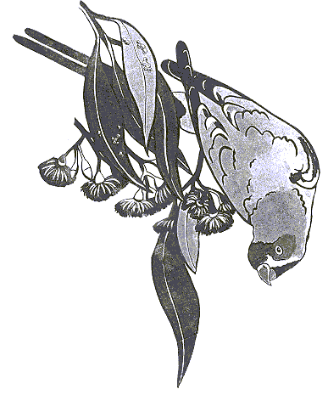Swift Parrot-Regent Honeyeater Record Sheet
Name/s:
Postal Address:
Postcode: ............... ………….Mobile:
Home Ph: (…) …………Work Ph: (…)
Email:

Site Details
Location (or distance and direction from nearest named landmark or town):

Date: Time started: Time finished: ….
Number of observers:………………………………..Altitude:
Additional Information Attached (such as maps & further descriptions): Yes / No
Topography (please circle): Plain / Gully / Slope / Ridge

Map details
Map No: …… Map Name & Scale: …………………………GPS used: Yes/No GPS Datum:………….
Zone:…… Easting:…………………….. Northing: ...……(eg East: 243560 North: 6027450)
Lat: …..Long: ……(eg Lat: 33º40’15” Long: 150º45’10”)

Weather Conditions
Cloud Cover (please tick box) |  |  | Wind Conditions (please tick box)
Clear |  |  | Calm
Patchy/overcast |  |  | Light Breeze
Raining |  |  | Windy

Swift Parrot (SP) / Regent Honeyeater (RH) observations
Number Swift Parrots (including 0):…………….Number Regent Honeyeaters (including 0):
Activity (e.g. foraging, aggression, perching):

Food/Habitat Resources Used:

Other bird species present (regardless of whether SP/RH recorded)
Key: 0 = None, 1 = Scarce, 2 = Common, 3 = Abundant
Other bird species | Abundance  (Use Key) | Aggression with SP/RH (/) | Other bird species | Abundance  (Use Key) | Aggression with SP/RH  (/)
Noisy Friarbird |  |  | White-naped Honeyeater
Little Friarbird |  |  | White-cheeked Honeyeater
Red Wattlebird |  |  | New Holland Honeyeater
Little Wattlebird |  |  | Eastern Spinebill
Noisy Miner |  |  | Scarlet Honeyeater
Bell Miner |  |  | Scaly-breasted Lorikeet
Yellow-faced Honeyeater |  |  | Musk Lorikeet
Fuscous Honeyeater |  |  | Little Lorikeet
Lewins Honeyeater |  |  | Purple-crowned Lorikeet
White-plumed Honeyeater |  |  | Rainbow Lorikeet
Yellow-tufted Honeyeater |  |  | Striated Pardalote
Brown-headed Honeyeater |  |  | Spotted Pardalote
Black-chinned Honeyeater

Habitat Description

Inland habitat type (please tick box) |  |  | Coastal habitat type (please tick box)
Grassy Woodland |  |  | Swamp Mahogany Forest
Box-Ironbark Woodland |  |  | Spotted Gum Forest
Riverine Woodland |  |  | Forest Red Gum Forest
Other |  |  | Banksia Heath
 |  |  | Other

Key: 0 = None, 1 = Scarce, 2 = Common, 3 = Abundant (DBH = Diameter at Breast Height)
Tree/Plant Species | On Site  () | SP/RH foraging  (/) | Flowering  (Use key) | Lerps/ Other Food Present  (Use key) | Trees  >40cm DBH  (Use Key) | Trees  >60cm DBH  (Use key)
Inland Habitats
Caley’s Ironbark
Red Ironbark
Mugga Ironbark
Grey Ironbark
Yellow Box
White Box
Grey Box
Red Box
Long-leaved Box
Yellow Gum
Blakely’s Red Gum
River Red Gum
Red Stringybark
River Oak/Casuarina
Mistletoe (specify)
Coastal habitats
Spotted Gum
Swamp Mahogany
Forest Red Gum
Broad-leaved Ironbark
Narrow-leaved Ironbark
White Stringybark
Blue-leaved Stringybark
Coastal Banksia
Mistletoe (specify)

Site Map/Additional Information
Eg simple map, shrub species present, direction of flight etc

