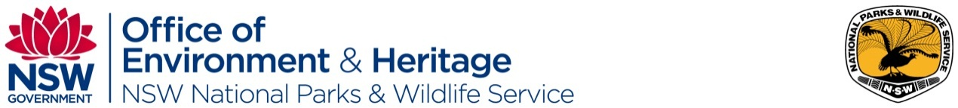

NSW National Parks and Wildlife Service
Commercial Tour Operator Small Grant Program 2016 – Expression of Interest
(Please complete one EOI form for each project)
Please ensure that you have read the information for applicants guide

About your business

Applicant information
Name |  | Business name
ABN |  | Parks Eco Pass licence number (if applicable, please also note if licence is in progress)
Email |  | Phone number

Describe your current business
(Please provide an overview of your current business, e.g. how many staff and/or guides do you have? How regularly do you operate? Where do you currently operate? How seasonal is your business and what are your peak, shoulder and low seasons, etc.?)

About your experience and customers
(Please provide an overview of your current business, e.g. what visitor experiences do you currently offer? Who is your market? How are your experiences positioned and priced in the market? How many people participate in each experience, etc.?)

About your potential project

Project name:

Which Landscape and NPWS park/s
(Please list the park/s where the experience/s will take place. Please identify the appropriate Landscape – see maps and park list available at NPWS Commercial Tour Operator Grant Program)
National Landscape (delete as appropriate) | Parks/s list
Australian Alps
Australia’s Coastal Wilderness
Australia’s Green Cauldron
Greater Blue Mountains
Sydney Harbour

Project outline
(Provide a brief outline of the project – no more than 150 words)

How would your proposed new (or enhanced) visitor experience increase your visitors’ levels of conservation, environmental education, awareness, and appreciation of national parks and natural areas?
(Provide a brief description, no more than 150 words)

How would your proposed new (or enhanced) visitor experience deliver on the themes or destination priorities identified within the Experience Development Strategy (EDS) for the relevant National Landscape?
(Provide a brief description, no more than 150 words)

Please outline immediate impediments to this project progressing and how you will manage these impediments?
(E.g. My Parks Eco Pass licence is not valid in this park/not valid for this activity/ currently in progress/being renewed, this activity is not identified in the Plan of Management, there are a number of other commercial operators undertaking this activity etc.)

What are the key factors to success in delivering this project?
(E.g. does it rely on improved or new infrastructure, access to a new area, separation from other existing visitor experiences, interpretation materials, identification of suitable partners etc.)

Are there any examples of this experience in other parts of NSW, Australia or the world?
(Please list, including relevant websites.)

Have you thought about any potential partners in delivering this project? Who might they be?
(Please add lines as you need to)
Business type (accommodation, transport, catering, interpretation, etc.)  If you are a non-Parks Eco Pass operator please identify on-park partner type/name | Off-park operator  Answer yes/no | How will this partner contribute to the project? (experience delivery, financial, logistical support, in-kind etc.)

Estimate of funding required
(Please provide a rough approximation of project budget)
 | Amount | Key budget items
Grant funding
Cash contribution
In-kind contribution
Total project funding

Grant program workshops

What topic areas would you like to see covered in the grant program workshop if you are required to attend?

How do you think the grant program workshop will assist you to develop your full application?

Other comments

Submission
Submit your completed expression of interest to tourism.partnerships@environment.nsw.gov.au by 10am Monday 23 May 2016.

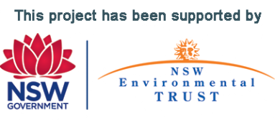

OEH 2016/0269 May 2016

