environment.nsw.gov.au
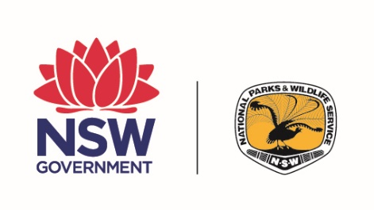
NSW National Parks & Wildlife Service

Parks Eco Pass
tour operator annual report
  - [COMPANY NAME / ABN GOES HERE]
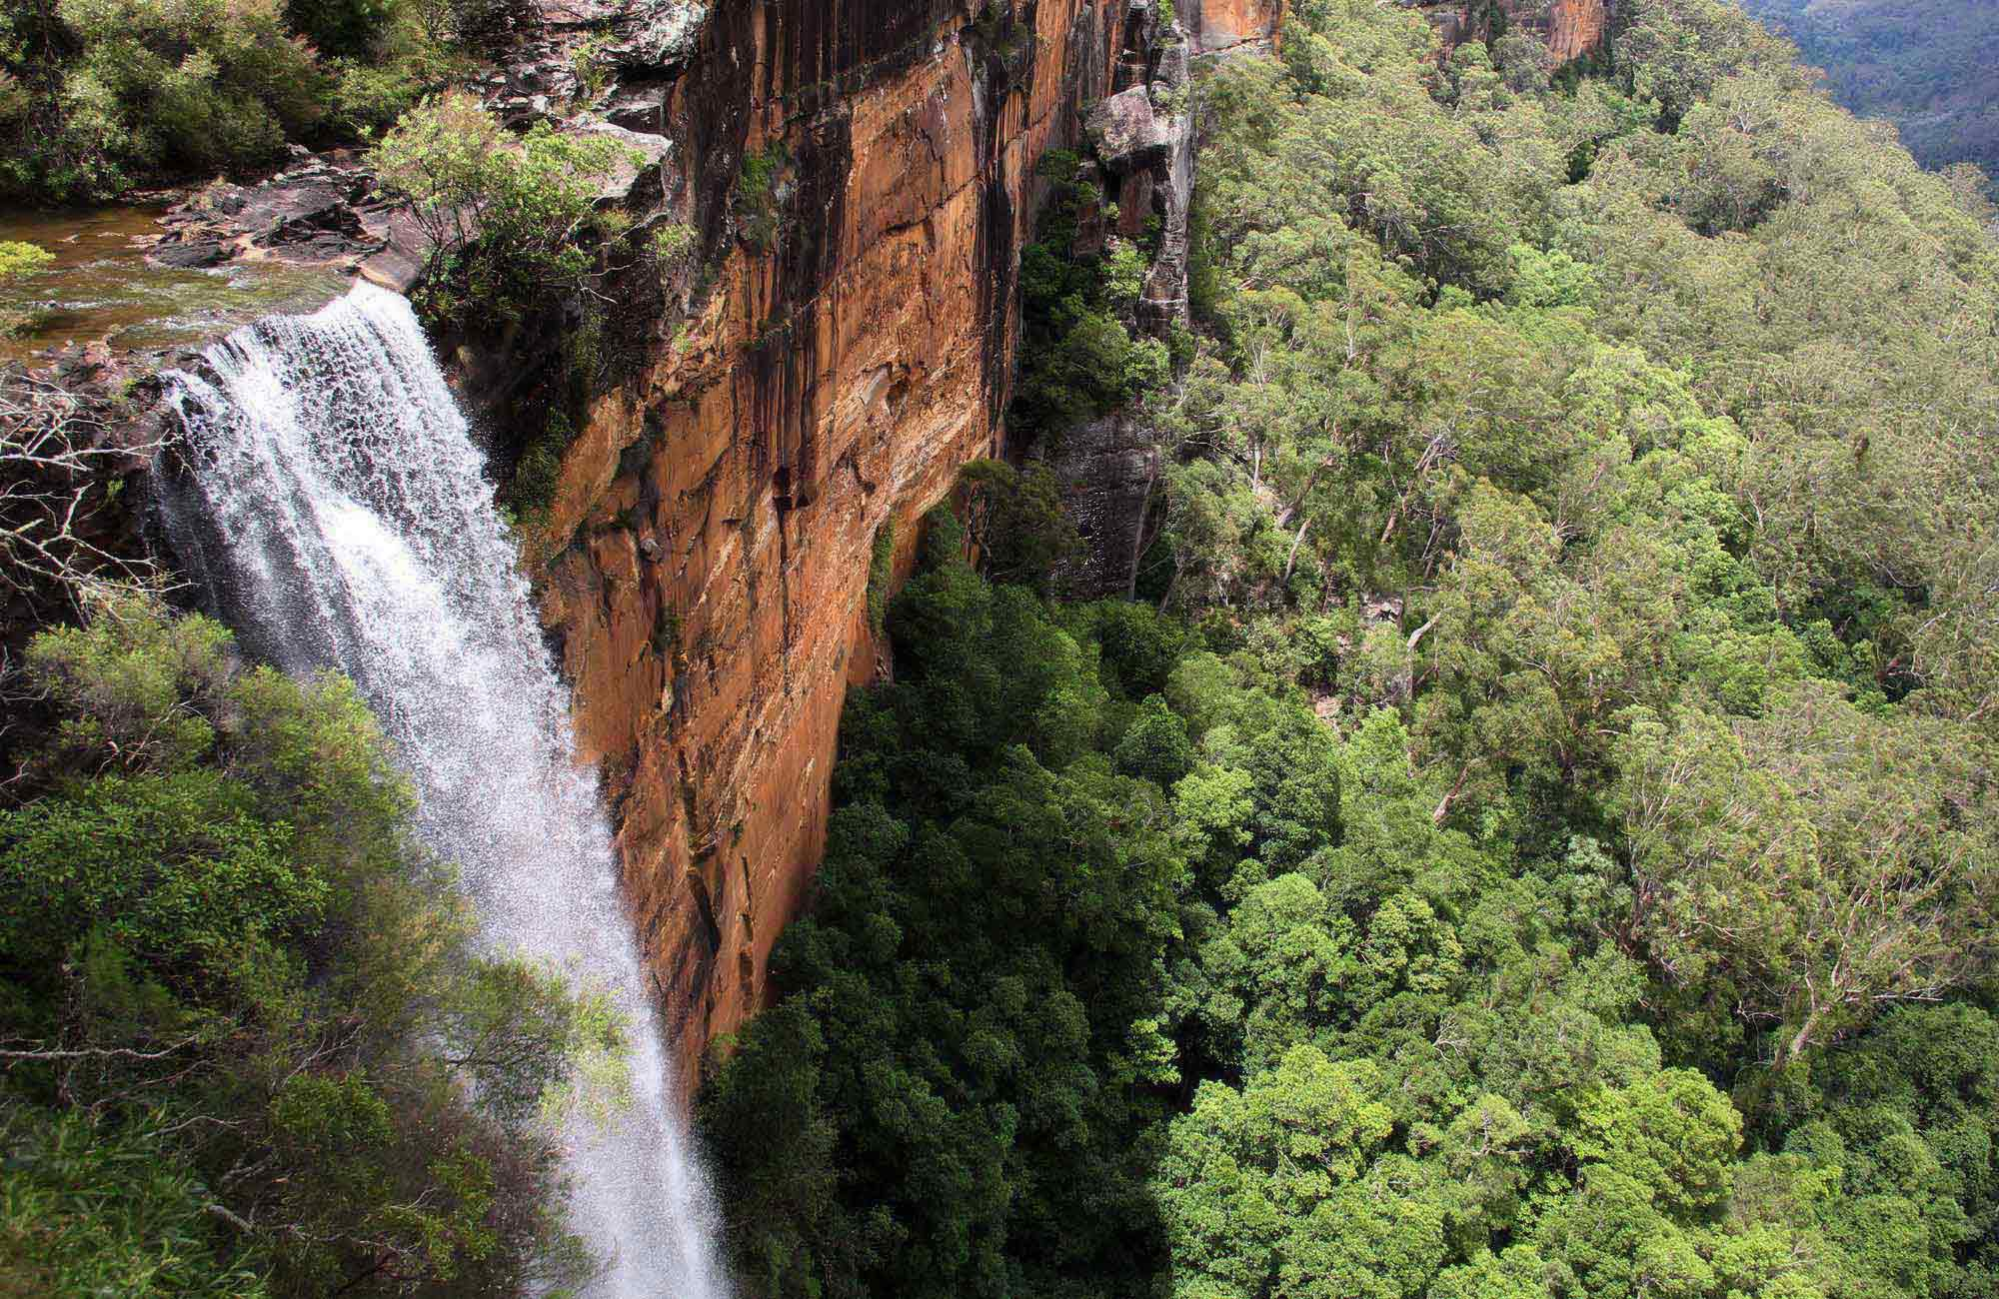
© 2020 State of NSW and Department of Planning, Industry and Environment
With the exception of photographs, the State of NSW and Department of Planning, Industry and Environment are pleased to allow this material to be reproduced in whole or in part for educational and non-commercial use, provided the meaning is unchanged and its source, publisher and authorship are acknowledged. Specific permission is required for the reproduction of photographs.
The Department of Planning, Industry and Environment (DPIE) has compiled this report in good faith, exercising all due care and attention. No representation is made about the accuracy, completeness or suitability of the information in this publication for any particular purpose. DPIE shall not be liable for any damage which may occur to any person or organisation taking action or not on the basis of this publication. Readers should seek appropriate advice when applying the information to their specific needs.
All content in this publication is owned by DPIE and is protected by Crown Copyright, unless credited otherwise. It is licensed under the Creative Commons Attribution 4.0 International (CC BY 4.0), subject to the exemptions contained in the licence. The legal code for the licence is available at Creative Commons.
DPIE asserts the right to be attributed as author of the original material in the following manner: © State of New South Wales and Department of Planning, Industry and Environment 2020.
Cover photo: View of Fitzroy Falls from the lookout, Morton National Park
John Yurasek/DPIE
Published by:
Environment, Energy and Science
Department of Planning, Industry and Environment
Locked Bag 5022, Parramatta NSW 2124
Phone: +61 2 9995 5000 (switchboard)
Phone: 1300 361 967 (Environment, Energy and Science enquiries)
TTY users: phone 133 677, then ask for 1300 361 967
Speak and listen users: phone 1300 555 727, then ask for 1300 361 967
Email: info@environment.nsw.gov.au
Website: www.environment.nsw.gov.au
Report pollution and environmental incidents
Environment Line: 131 555 (NSW only) or info@environment.nsw.gov.au
See also www.environment.nsw.gov.au
ISBN 978-1-922431-39-4
EES 2020/0281
July 2020
Find out more about your environment at:
www.environment.nsw.gov.au

When you use this template to create a Parks Eco Pass tour operator annual report, replace this imprint page with your own publication details or approvals page.

Contents
1. Summary of activities 2
2. Codes of practice 2
3. Continuous improvement 2

- Summary of activities
Please provide a summary of all activities you have conducted in the park(s) over the last 12 months.
For each park, please provide the following:
- number of tours
- number of visitors including % breakdown of domestic and international visitors.
Click or tap here to enter text.
- Codes of practice
Please provide evidence of how you have met the standards set by the codes of practice which were outlined in your business plan (up to 500 words).
Click or tap here to enter text.
- Continuous improvement
Please provide evidence of how you have continuously improved your business over the last 12 months as identified by your business plan (up to 500 words).
Click or tap here to enter text.

