environment.nsw.gov.au
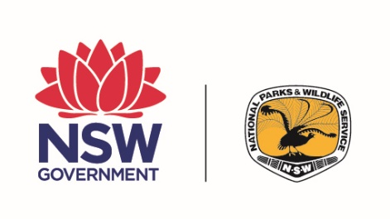
NSW National Parks & Wildlife Service

Parks Eco Pass
tour operator business plan
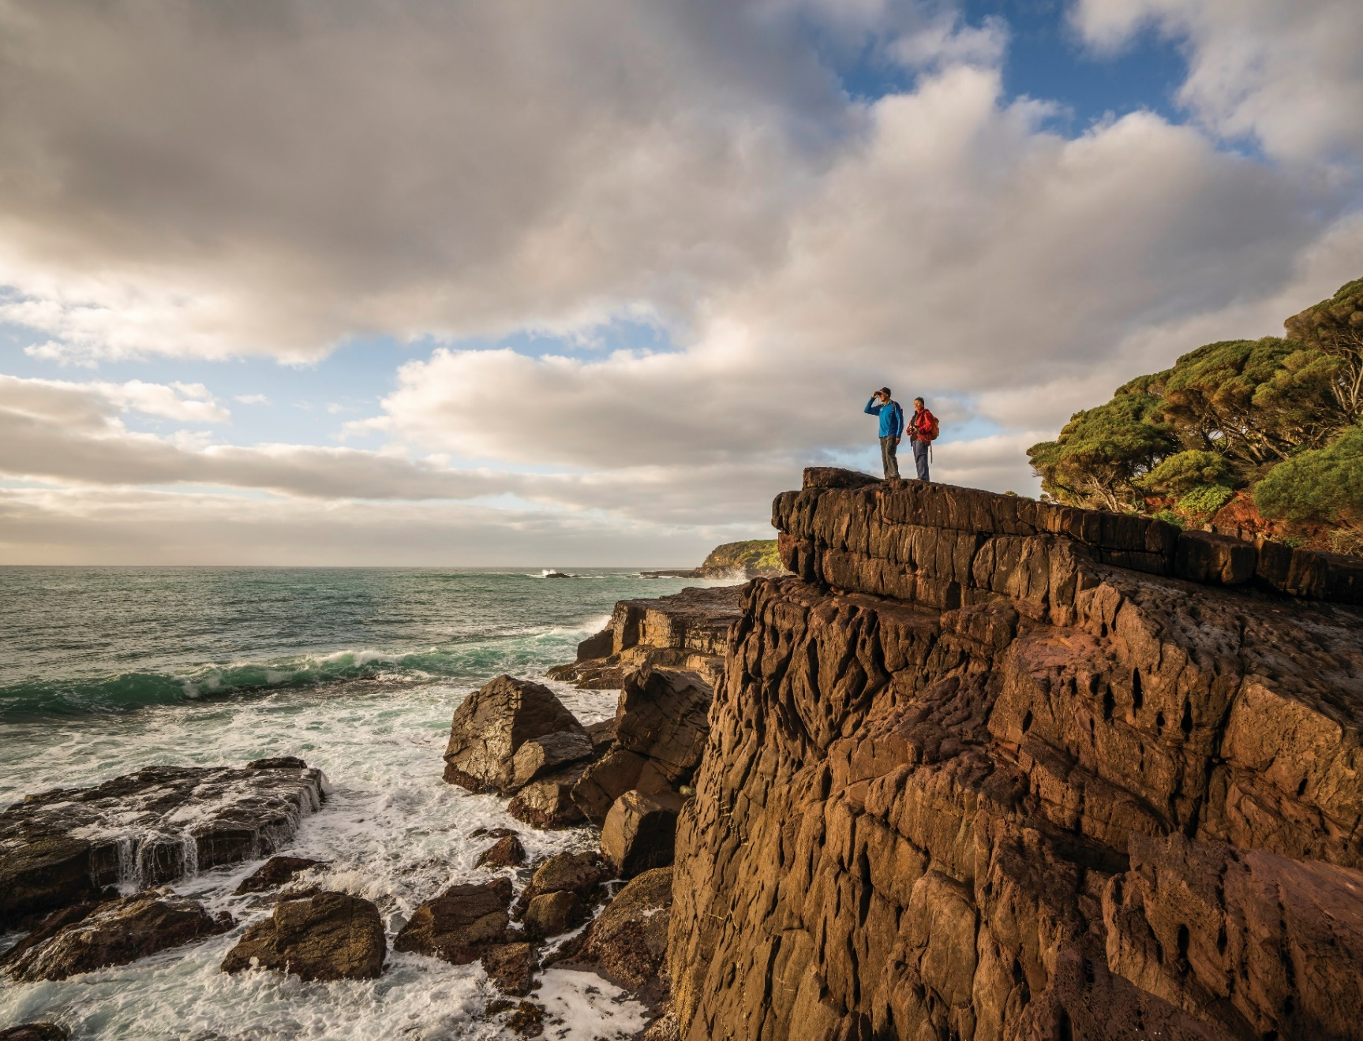
  - [Company name/ABN goes here]
© 2020 State of NSW and Department of Planning, Industry and Environment
With the exception of photographs, the State of NSW and Department of Planning, Industry and Environment are pleased to allow this material to be reproduced in whole or in part for educational and non-commercial use, provided the meaning is unchanged and its source, publisher and authorship are acknowledged. Specific permission is required for the reproduction of photographs.
The Department of Planning, Industry and Environment (DPIE) has compiled this report in good faith, exercising all due care and attention. No representation is made about the accuracy, completeness or suitability of the information in this publication for any particular purpose. DPIE shall not be liable for any damage which may occur to any person or organisation taking action or not on the basis of this publication. Readers should seek appropriate advice when applying the information to their specific needs.
All content in this publication is owned by DPIE and is protected by Crown Copyright, unless credited otherwise. It is licensed under the Creative Commons Attribution 4.0 International (CC BY 4.0), subject to the exemptions contained in the licence. The legal code for the licence is available at Creative Commons.
DPIE asserts the right to be attributed as author of the original material in the following manner: © State of New South Wales and Department of Planning, Industry and Environment 2020.
Cover photo: Whale watching, Bittangabee campground, Ben Boyd National Park
Photo: John Spencer/DPIE
Published by:
Environment, Energy and Science
Department of Planning, Industry and Environment
Locked bag 5022, Parramatta NSW 2124
Phone: +61 2 9995 5000 (switchboard)
Phone: 1300 361 967 (Environment, Energy and Science enquiries)
TTY users: phone 133 677, then ask for 1300 361 967
Speak and listen users: phone 1300 555 727, then ask for 1300 361 967
Email: info@environment.nsw.gov.au
Website: www.environment.nsw.gov.au
Report pollution and environmental incidents
Environment Line: 131 555 (NSW only) or info@environment.nsw.gov.au
See also www.environment.nsw.gov.au
ISBN 978-1-922431-48-6
EES 2020/0282
July 2020
Find out more about your environment at:
www.environment.nsw.gov.au

When you use this template to create a Parks Eco Pass tour operator business plan, replace this imprint page with your own publication details or approvals page.

Contents
Instructions iii
1. Overview of business 4
2. Codes of practice 4
2.1 Environment 4
2.2 Staff 5
2.3 Customer Service 5
3. Industry standards 5
4. Details of interpretive messages 5
5. Organisation 6
5.1 Corporate Structure 6
5.2 Staff competencies/qualifications, training and development 6
6. Emergency response plan 6
7. Responsible marketing 7
8. Continuous improvement 7

Instructions
This template provides the sections and subsections that you need to include in your business plan. Each section or subsection includes guidance notes on what to include and, in some cases, a word limit. Please replace the guidance notes and word limit text with the information relevant to your company/operation.

- Overview of business
[Up to 200 words]
Please provide a summary of your business.
Please include the following:
- What does your business do? Include what activities you would like to conduct in the park.
- Which parks would you like to operate in?
- Who is your target market?
- What is your unique selling point(s)?
- How many visitors do you expect to attract to the parks?
Click or tap here to enter text.
- Codes of practice
Please provide an outline of how your business objectives and standards relate to the environment, your staff and customer service.
  - Environment
[Up to 500 words].
Provide details of how your business will fulfil the following environmental requirements. Specific environmental sustainability and minimal impact practices and expectations will vary depending upon your type of activity.
- Explain to customers how negative impacts on sites can be avoided.
- Build an understanding of natural and cultural heritage conservation management.
- Provide good interpretation and education.
- Honour historic places.
- Promote respect for Aboriginal culture and sites.
- Observe rules to protect conservation values and public safety.
- Encourage active involvement in conservation activities.
- Adopt environmental practices which support environmental sustainability.
- Adopt minimal impact practices for all activities.
Click or tap here to enter text.

  - Staff
[Up to 200 words].
Provide details of the standards you expect from your staff and an outline of your ‘corporate’ philosophy. For example, you could include details of the values you expect from your staff (such as friendly, supportive, organised and well-prepared).
Click or tap here to enter text.
  - Customer Service
[Up to 200 words].
Provide details of your customer service philosophy and goals.
Click or tap here to enter text.
- Industry standards
Provide details of any industry standards, such as Outdoor Council of Australia – Australian Adventure Activity Standards and Good Practice Guides, that you have adopted or that apply to your operations.
Industry standards are voluntary guidelines describing industry-recognised standards of practice and have been developed for many activities, such as bushwalking, camping, adventure activities, horse riding and inland water paddle-craft.
Click or tap here to enter text.
- Details of interpretive messages
NPWS expects Parks Eco Pass operators to provide high quality interpretation of the natural environment and culturally appropriate interpretation of historic and Aboriginal heritage. However, we do recognise that the level of interpretive content will differ depending on the type of activity. For example, an adventure activity such as abseiling or canyoning may involve less interpretive content than a guided bushwalk.
It is important to note that if you wish to undertake detailed, rather than general, Aboriginal cultural heritage interpretation on country, on site or otherwise, you must employ or otherwise engage members of the relevant Aboriginal community to undertake the interpretation, and obtain a letter of support every three years from an Aboriginal organisation that is representative of the local community.
General interpretation includes information in the public domain, the traditional name of a place and its meaning and the traditional name(s) of the local Aboriginal communities.
Please provide details of the messages you hope to convey through your tourism/recreation product and the content of your activities.
Click or tap here to enter text.
- Organisation
Provide details of the ‘corporate’ structure of your organisation along with staff competencies/qualifications, training and development.
  - Corporate Structure
Insert Corporate Structure here.
Click or tap here to enter text.
  - Staff competencies/qualifications, training and development
You must ensure that all your guides and employees have and maintain the relevant competencies and skills for leading and guiding your activities. Please provide details of your staff skills, qualification and experience requirements.
You may also have guidelines, such as guides/instructors’ handbooks (including lists of duties and terms of employment), that you have prepared for your staff in relation to your activities. Please also provide details of ongoing training and performance monitoring.
Click or tap here to enter text.
- Emergency response plan
You must provide and maintain an Emergency Response Plan for each activity which outlines procedures to be followed in the event of natural or other disaster, injury, illness or delay. Foreseeable risks should be identified, and strategies should be developed to avoid or minimise these risks. Your plan must include information to assist your staff to minimise the escalation of the situation, the injuries incurred and the likelihood of further incidents occurring.
Your industry body may well provide established risk management guidelines that you may adapt to your specific business. However, your plan must be specific to your planned activities.
Your staff must be familiar with your Emergency Response Plan and able to access a copy when carrying out the activity. Provide as much detail as possible to properly assess and manage risk in your business operations.
Your Emergency Response Plan should include details on the following areas:
- identifying hazards and assessing risks
- management of risks
- incident/emergency response procedures and a copy of your activity incident report
- client - staff ratios
- activity equipment standards
- first aid qualifications and equipment
- equipment maintenance and replacement procedures
- weather contingencies
- documentation and record keeping.
An effective risk management plan should involve the following series of steps (Australian Standard AS/NZS 4360 Risk Management):
- Step 1 – Identify all hazards.
- Step 2 – Assess and prioritise the risks these hazards create, deal with highest priority risk first.
- Step 3 – Decide on measures to control the risks (e.g. eliminate the risk, substitute a venue and use personal protective equipment).
- Step 4 – Implement appropriate control measures.
- Step 5 – Monitor the control measures and review the process.
Click or tap here to enter text.
- Responsible marketing
[Up to 200 words]
Provide details of your marketing policies and practices.
Click or tap here to enter text.
- Continuous improvement
[Up to 200 words]
A final key element of any business plan is a policy on how to continuously improve your business.
Think about quality standards and accreditation, monitoring procedures, client profiles, client satisfaction reports, environmental performance guidelines and goals and risk management procedures
Please provide details of your continuous improvement business practices.
Click or tap here to enter text.

