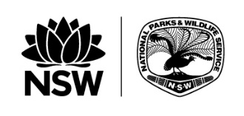
Office of Environment and Heritage
Parks Ecopass Payment form 2018-19

Your details
Name
Organisation’s trading name
Contact phone number

Fees
The licence administration fees are GST inclusive. There is no charge for the deletion of an activity.
One-year licence fee | ☐ $265.00
Three-year licence fee | ☐ $954.00 at 318.00 per year
Ten-year licence annual fee | ☐ $3700.00 at 370.00 per year
Major amendment fee | ☐ $200.00 transfer application  ☐ $200.00 new tour or activity
Minor amendment fee | ☐ $50.00 variation in existing tour or activity  ☐ $50.00 additional guide or vehicle ID tags (up to 10)  ☐ $50.00 new subcontractor
Licence restoration fee | ☐ $50.00

Method of payment
Cheque for $ payable to Office of Environment and Heritage.
Please charge my credit card $ ☐ Mastercard ☐ Visa
Name of card holder
Expiry date
Card number
Cardholder’s signature
Print or email this completed form to:
Parks Eco Pass
Visitor Experience Branch
Parks and Wildlife Group
PO Box 1967
Hurstville, NSW 1481
Email: park.businesses@environment.nsw.gov.au
Phone: 02 9585 6082

