

NEW SOUTH WALES
COMMERCIAL KANGAROO HARVEST
MANAGEMENT PLAN

2012 – 2016

© Copyright Office of Environment and Heritage on behalf of State of NSW
The Office of Environment and Heritage and the State of NSW are pleased to allow this material to be reproduced in whole or in part for educational and non-commercial use, provided the meaning is unchanged and its source, publisher and authorship are acknowledged.
Published by:
Office of Environment and Heritage
Department of Premier and Cabinet (NSW)
59-61 Goulburn Street, Sydney, NSW 2000
PO Box A290, Sydney South, NSW 1232
Phone: (02) 9995 5000 (switchboard)
Phone: 131 555 (environment information and publications requests)
Phone: 1300 361 967 (national parks, climate change and energy efficiency information, and publications requests)
Fax: (02) 9995 5999
TTY: (02) 9211 4723
Email: info@environment.nsw.gov.au
Website: www.environment.nsw.gov.au

Report pollution and environmental incidents
Environment Line: 131 555 (NSW only) or info@environment.nsw.gov.au
See also www.environment.nsw.gov.au/pollution

This document is also available on the Office of Environment and Heritage website at www.environment.nsw.gov.au by following the links to ‘Kangaroo Management’.
This document should be cited as: Office of Environment and Heritage (NSW) 2011, New South Wales Commercial Kangaroo Harvest Management Plan 2012–2016, Office of Environment and Heritage, Department of Premier and Cabinet (NSW), Sydney.

ISBN 978 1 74293 442 6
OEH 2011/0975
December 2011
CONTENTS
1. INTRODUCTION 1
2. LEGISLATIVE FRAMEWORK 2
2.1. Commonwealth 2
2.2. New South Wales 2
3. BIOLOGY, ECOLOGY AND CONSERVATION OF KANGAROOS 10
3.1. Introduction 10
3.2. Biology and Ecology 10
3.3. Conservation Status 19
3.4. Threats, issues and assessment of impacts 19
4. GOAL AND AIMS 23
4.1. Goal 23
4.2. Aims 24
5. MANAGEMENT ACTIONS AND PERFORMANCE INDICATORS 25
REFERENCES 38
Appendix A – Setting and applying harvest thresholds 45
FIGURES
Figure 1: Current New South Wales Kangaroo Management Zones 3
Figure 2: New South Wales commercial kangaroo licensing flow chart 4
Figure 3: Distribution of red kangaroo (Macropus rufus) 15
Figure 4: Distribution of eastern grey kangaroo (Macropus giganteus) 16
Figure 5: Distribution of western grey kangaroo (Macropus fuliginosus) 17
Figure 6: Distribution of wallaroo (Macropus robustus) 18
Figure 7: Histogram of a theoretical population of kangaroos. 46
Figure 8: A theoretical distribution after z-score transformation. 47
Figure 9: Example of setting harvest thresholds for red kangaroos in Zone 2. 48
Figure 10: 10,000 simulations for a population fluctuating over 20 years. 49
Figure 11. Simulated population as described for Figure 10. 50
TABLES
Table 1: The New South Wales, Commonwealth, IUCN and CITES conservation status of the kangaroo species to which this plan relates 19
Table 2: Threats and issues pertinent to the conservation status of kangaroos 21
Table 3: Impacts of the commercial kangaroo harvest on other species, habitat and ecosystems 22

DEFINITIONS
Carcase – the entire body (including the skin) of the kangaroo, excluding the head and viscera.
National Code of Practice for the Humane Shooting of Kangaroos and Wallabies for Commercial Purposes – the current nationally-endorsed Code, endorsed by the Natural Resource Management Ministerial Council in 2008. A reference to this Code will also apply to any subsequently nationally-endorsed codes.
Harvester – a person licensed under section 123 of the National Parks and Wildlife Act 1974 to harvest kangaroos for commercial purposes.
Chiller premise – a refrigerated facility used for the temporary storage of kangaroo carcases until collection and transport to a processing works.
Ecologically sustainable development – this plan employs the definition contained in the Environment Protection and Biodiversity Conservation Act 1999. In general this definition includes the precautionary principle; inter-generational equity; conservation of biological diversity and ecological integrity; and improved valuation of environmental factors.
Landholder – owner or occupier of specified lands.
Kangaroo – the kangaroo species that can be utilised in accordance with this management plan: the red kangaroo (Macropus rufus), western grey kangaroo (M. fuliginosus), eastern grey kangaroo (M. giganteus) and wallaroo (M. robustus erubescens and M. robustus robustus).
Note: All other definitions have the meaning prescribed in the National Parks and Wildlife Act 1974.

1. INTRODUCTION
This management plan has been developed to satisfy the requirements of the Commonwealth's Environment Protection and Biodiversity Conservation Act 1999 (EPBC Act) and to meet the legislative and other requirements of the NSW Government.
This management plan relates only to the commercial harvest of the following kangaroo species within NSW:
- red kangaroo (Macropus rufus)
- eastern grey kangaroo (Macropus giganteus)
- western grey kangaroo (Macropus fuliginosus)
- wallaroo (Macropus robustus, including both M. r. erubescens and M. r. robustus).
Where the term kangaroo is used within this document it refers to all of the aforementioned macropod species and subspecies.
This management plan is current for a maximum five-year period from 01 January 2012 to 31 December 2016.
In Australia the export of kangaroo products requires Commonwealth Government approval under the EPBC Act.
Under the NSW National Parks and Wildlife Act 1974 (the NPW Act), kangaroos are 'protected fauna' and the NSW Office of Environment and Heritage (OEH) is responsible for the 'protection and care of fauna'. The utilisation of kangaroos in NSW is regulated under the NPW Act and NSW National Parks and Wildlife Regulation 2009 (the Regulation) through the issue of various licences and tags.
This management plan does not provide the framework for the management of kangaroos within land dedicated or declared under Part 4 or Part 4A of the NPW Act and managed by OEH e.g. national parks and nature reserves. Kangaroos cannot be commercially taken in such conservation reserves, approximately 6.3% of the commercial harvest zones with a total area in excess of four million hectares.
This plan relates only to the commercial harvest of kangaroos within NSW. The non-commercial culling of kangaroos in NSW is not regulated by this plan. OEH regulates the non-commercial culling of kangaroos through the provisions of the NPW Act.
The primary goal of the management plan is to ensure that the commercial harvest of kangaroos is ecologically sustainable. This will be achieved through the application of the best available scientific knowledge and best practice management and monitoring of outcomes to ensure the viability of kangaroo populations is not compromised by any action undertaken in accordance with this plan.
This management plan incorporates an adaptive approach to management. Adaptive management is the systematic acquisition and application of reliable information to improve management over time. The adaptive management provisions of this plan facilitate the investigation of different strategies using scientifically rigorous experimentation to not only support appropriate adjustments to management practices, but to improve knowledge and inform future program reviews.
This plan will set the framework for the commercial harvest of kangaroos in order to provide for the management of kangaroo populations in accordance with the principles of ecologically sustainable development. Management in this context provides for the sustainable harvesting of kangaroos for products such as meat and leather to supply the Australian and international markets. Management also assists in balancing environmental, social and economic interests through the collaborative management of a sustainable resource.
This plan prohibits the taking of kangaroos for skins only.

2. LEGISLATIVE FRAMEWORK

2.1. Commonwealth
The relevant provisions under the EPBC Act came into force on 11 January 2002, following the incorporation of the former Wildlife Protection (Regulation of Exports and Imports) Act 1982. The EPBC Act provides legislative provisions requiring the development and approval of wildlife trade management plans in order for permits to be issued for the commercial export of wildlife products.
The EPBC Act states that the Commonwealth minister responsible for the environment may approve a wildlife trade management plan for a maximum of five years. The EPBC Act specifies that such approval must only be given if the Minister is satisfied that:
- the plan is consistent with the objects of Part 13A of the EPBC Act
- an assessment of the environmental impacts of the activities in the plan has been undertaken
- the plan includes management controls directed towards ensuring the impacts of the activities covered by the plan are ecologically sustainable
- the activities in the plan are not detrimental to the species to which the plan relates or any relevant ecosystem
- the plan includes measures to mitigate, monitor and respond to the environmental impacts of the activity covered by the plan.
In deciding whether to declare a plan, the Minister must also have regard to whether:
- legislation relating to the protection, conservation or management of the specimens to which the plan relates is in force in the State or Territory concerned
- the legislation applies throughout the State or Territory concerned
- in the opinion of the Minister, the legislation is effective.
Finally, in resolving whether to declare a plan, the Minister must also be satisfied that if an animal is killed, it is done in a way that is generally accepted to minimise pain and suffering. Animal welfare standards for the commercial harvesting of kangaroos are detailed in the National Code of Practice for the Humane Shooting of Kangaroos and Wallabies for Commercial Purposes (www.environment.gov.au/biodiversity/trade-use/wild-harvest/kangaroo/practice.html). All kangaroos must be taken in accordance with this Code or any subsequent relevant nationally-endorsed codes that replace that document.

2.2. New South Wales
All kangaroo species and subspecies are ‘protected fauna’ in NSW under the NPW Act. However, the NPW Act and the Regulation make provision for the licensing of a range of activities relating to the commercial harvesting of kangaroos in NSW.
Kangaroos can only be taken in accordance with this management plan under a licence issued by OEH. Moreover, under this management plan the commercial harvesting of kangaroos in NSW is presently restricted to the commercial Kangaroo Management Zones illustrated in Figure 1. However, within the life of this plan new commercial kangaroo harvesting zones may be opened, on the basis of population surveys, in areas of NSW where commercial harvesting of kangaroos is not currently occurring.
The licensing process as it relates to kangaroo harvesting is summarised in Figure 2 and described in more detail below. The licensing process commences with a landholder applying for an occupier's licence and nominating a licensed harvester to undertake the shooting. Both a harvester’s licence and an occupier’s licence are required for the commercial harvest of kangaroos. Other activities associated with the commercial use of kangaroos require licences specific to those activities (such as fauna dealer’s and skin dealer’s licences).
Figure 1: Current New South Wales Kangaroo Management Zones
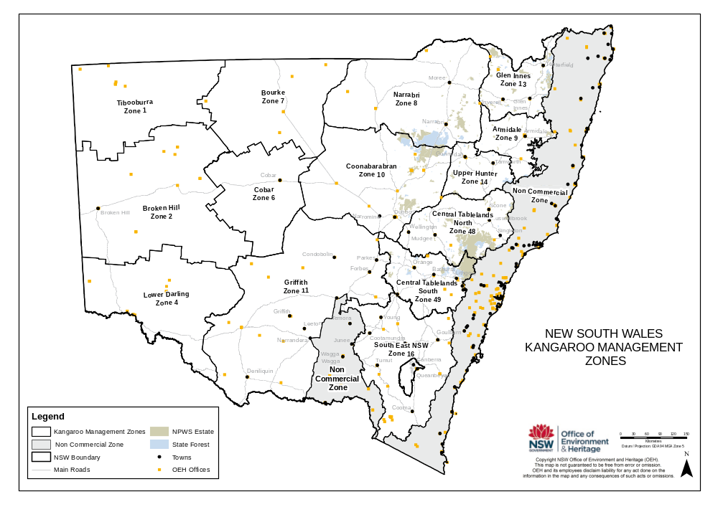
Figure 2: New South Wales commercial kangaroo licensing flow chart

Landholder applies to OEH for an occupier's licence to shoot kangaroos

Landholder nominates licensed harvester to shoot commercially

- occupier's licence assessed and issued by an authorised OEH officer
- licence specifies the number of each kangaroo species authorised to be shot. The number authorised to be shot must be within the quota
- plastic tags issued with licence (NPW Regulation)
- harvester shoots kangaroos and field dresses carcases
- harvester attaches tags to kangaroo carcases
- harvester delivers kangaroo carcases to chiller premises registered by fauna dealer under s124 of the NPW Act
- fauna dealer transports kangaroos to registered premises for processing or sells to another fauna dealer
- skin removed and meat and skin processed
- skin processed at registered premises
- tag removed during processing of skin
- whole carcases and skins, processed meat and processed skins can be exported from NSW or imported into NSW pursuant to licence issued under s126 of the NPW Act.

Occupier’s Licence
Issued under section 121 of the National Parks and Wildlife Act 1974
As it relates to commercial kangaroo harvesting, an occupier's licence entitles the holder to:
- permit a person holding a harvester's licence issued under section 123 to kill a specified number of kangaroos on the occupier's lands.
The licence states which species, and how many of that species may be taken under the authority of the licence. All kangaroos must be taken in accordance with the National Code of Practice for the Humane Shooting of Kangaroos and Wallabies for Commercial Purposes. Pouch young and young at foot that are euthanized in accordance with this Code of Practice are not included in the total authorised to be taken.
For commercial kangaroo harvesting, an occupier's licence is subject to a condition requiring tags to be affixed or attached to the carcase of all kangaroos taken under the authority of the licence. The licence must not be issued unless the licensee has been supplied by OEH with sufficient tags to enable the licensee to comply with the relevant condition. For further details on the issue of tags refer to section below.
Before approving an application for an occupier's licence, an authorised OEH officer will consider relevant information, including confirming that:
- the application has the landholder's original handwritten signature
- the applicant is the legal occupier of the land, or has been authorised by the occupier to make the application
- the number of each kangaroo species the applicant seeks to take is within the commercial quota for that species in that Kangaroo Management Zone
- the person the occupier has nominated to shoot the kangaroos is licensed under s123 - that is, holds a harvester's licence.
Occupier's licences are subject to conditions that include, but are not limited to:
- Tags must only be used on the property for which they were issued within the valid period of the licence.
- Tags must only be used by the harvester nominated on the licence.
- Unused tags must be returned to OEH at the expiry of the licence.
- Not more than the number of each species stated on the licence may be killed.

Harvester’s Licence
Issued under section 123 of the National Parks and Wildlife Act 1974
As it relates to commercial kangaroo harvesting a harvester's licence authorises the holder to:
- kill kangaroos for the purposes of sale.
A harvester's licence does not authorise the taking of kangaroos in lands dedicated or declared under Part 4 or Part 4A of the NPW Act and managed by OEH e.g. national parks and nature reserves.
Before approving an application for a harvester’s licence, an authorised OEH officer will consider relevant information, including confirming that:
- the applicant holds a current valid Firearms Licence that allows the person to possess and use the appropriate firearm
- the applicant has successfully completed the endorsed accreditation program for harvesters, and that accreditation is current
- the application has the applicant's original handwritten signature.
The applicant must also provide evidence that they have successfully completed NSW TAFE course 5725 – Australian Game Meat Hygiene and Handling as required by the NSW Food Authority, or other appropriate training as advised by the NSW Food Authority.
Harvester's licences are subject to conditions that include, but are not limited to:
- All kangaroos must be shot in accordance with the current National Code of Practice for the Humane Shooting of Kangaroos and Wallabies for Commercial Purposes (www.environment.gov.au/biodiversity/trade-use/wild-harvest/kangaroo/practice.html).
- The harvester must not possess or offer for sale any kangaroo carcase containing a bullet wound in the body.
- The harvester must immediately attach a plastic tag issued for use on that property to each kangaroo taken.
- Kangaroos may only be sold to the registered premises of a fauna dealer licensed under s124 of the National Parks and Wildlife Act 1974.
- The harvester must provide to OEH true and accurate monthly return(s) for each occupier's licence where the licensee was the nominated harvester.
- The harvester must only sell whole carcases with the skins attached.

Fauna Dealer’s Licence
Issued under section 124 of the National Parks and Wildlife Act 1974.
As it relates to commercial kangaroo harvesting a fauna dealer's licence authorises the holder to:
- buy or sell kangaroos as a fauna dealer at or on any premises that are registered under this section
- process kangaroo carcases at or on any premises that are registered under this section.
Before approving an application for a fauna dealer’s licence, an authorised OEH officer will consider relevant information, including confirming that:
- the application has been signed by a person with appropriate authority, where the applicant is a company
- the application falls within current OEH policy for the issuing of licences under this section
- registration certificates are to be issued for each of the premises at which the applicant proposes to carry on business as a fauna dealer in NSW, as required under s124(2).
Fauna dealer's licences are subject to conditions that include, but are not limited to:
- The fauna dealer must only purchase kangaroos from the holder of a current harvester’s licence or fauna dealer’s licence.
- The fauna dealer must not purchase, possess, process or sell a kangaroo carcase that contains a bullet wound in the body.
- The fauna dealer must only treat or store kangaroo skins or carcases at a registered premise.
- The fauna dealer must supply monthly returns to OEH in the form provided by OEH.
Chiller premises registered by Fauna dealers under this section are subject to conditions that include, but are not limited to:
- The licensee must comply with the conditions of the fauna dealers licence.
- The licensee must make the site open to inspection by an authorized OEH officer at all times.
- The licensee must supply weekly returns to OEH in the form provided by OEH.

Skin Dealer’s Licence
Issued under section 125 of the National Parks and Wildlife Act 1974.
As it relates to commercial kangaroo harvesting, a skin dealer's licence authorises the holder to:
- buy or sell kangaroo skins as a skin dealer at or on any premises that are registered under this section.
Before approving an application for a skin dealer’s licence, an authorised OEH officer will consider relevant information, including confirming that:
- the application has been signed by a person with appropriate authority, where the applicant is a company
- registration certificates are to be issued for each of the premises at which the applicant proposes to carry on business as a skin dealer in NSW, as required under s125.
Skin dealer's licences are subject to conditions that include, but are not limited to:
- The skin dealer must only purchase kangaroo skins from the holder of a current fauna dealer’s (kangaroo) or skin dealer’s (kangaroo) licence.
- The skin dealer must not have in his or her custody or control any kangaroo skin that does not have a commercial tag attached.
- The skin dealer must only treat or store kangaroo skins at a registered premises.
- The skin dealer must supply monthly returns to OEH in the form provided by OEH.

Import and Export Licence
Issued under section 126 of the National Parks and Wildlife Act 1974 pursuant to clauses 54 and 55 of the National Parks and Wildlife Regulation 2009.
As it relates to commercial kangaroo harvesting an import and export licence authorises the holder to:
- import or export kangaroos to or from NSW.
Before approving an application for an import or export licence, an authorised OEH officer will consider relevant information, including confirming that:
- the applicant is the holder of a current fauna dealer’s or skin dealer’s licence in NSW
- the import or export is in accordance with the current New South Wales Commercial Kangaroo Harvest Management Plan or an approved wildlife trade management plan in another state.
Import and export licences are subject to conditions that include, but are not limited to:
- The licensee must supply quarterly returns to OEH in the form provided by OEH.
- The licence number of the consignor must be clearly marked on each package containing protected fauna that is either imported or exported.

Tags
Tags are issued as a condition of an occupier’s licence under Section 121(2) and clauses 52 and 53 of the National Parks and Wildlife Regulation 2009.
- OEH must issue plastic tags in a quantity equal to the number of kangaroos a person is authorised to take under the occupier's licence.
- A fee (fixed by the Chief Executive) must be paid to OEH for the tags.
- The tags must be self-locking, from a series issued specifically for that year, individually numbered and a different colour for each consecutive year.
- Tags are issued for a specific property and harvester, and are not transferable to another property or harvester.
- The tags must be attached to the skin and locked to prevent removal.
- A tag can only be removed from the kangaroo skin during the skin tanning process.
- All kangaroos taken under a commercial licence must be tagged, whether or not the carcase is sold.

3. BIOLOGY, ECOLOGY AND CONSERVATION OF KANGAROOS

3.1. Introduction
Kangaroos are among the most widely studied species in Australia, largely as a consequence of the commercial harvest. The biology, ecology, conservation status, threats and issues relating to the conservation and harvesting of the kangaroo species that are the subject of this plan have been comprehensively documented in a large number of widely available publications. It is beyond the scope of this plan to reiterate the contents of these publications as they relate to kangaroos and their management. Accordingly, the following sections provide only a summary of the variety of publications that address specific aspects of kangaroo biology, ecology, conservation, management and harvesting and provide references to more detailed information where appropriate.

3.2. Biology and Ecology
The information in this section has largely been adapted from the background information for kangaroo management in commercial harvesting of kangaroos in Australia (Pople & Grigg 1999).

3.2.1. Introduction
The four kangaroo species that are the subject of this plan are abundant over a broad area of Australia and NSW (Figures 3 to 6). The three most abundant species (red kangaroo, eastern grey kangaroo and western grey kangaroo), which comprise about 97% of the commercial harvest, are particularly common over the sheep and cattle grazing pastures of western NSW. Within sheep rangelands, the provision of permanent watering points means kangaroos are now more likely to be limited by food than water (Oliver 1986). This has had a profound effect on their distribution as well as their abundance (Newsome 1965a). It has been suggested that sheep and cattle also improved the habitat of kangaroos through facilitative grazing; creating a sub-climax pasture (Newsome 1975). These changes to the environment would have been most pronounced in the late 1800s when average sheep numbers in the rangelands of NSW were nearly twice what they are today (Caughley 1976). Other changes were also wrought upon Australia's rangelands following European settlement – numerous species of eutherian herbivores and predators were introduced and became established in the wild; at the same time numerous small native mammal species disappeared and many are now extinct. As Caughley (1987b) explained, not only was the habitat modified, but the ecological system was 'changed beyond recognition'. The current distribution and abundance of kangaroos may therefore bear only a vague resemblance to what it was prior to European settlement.

3.2.2. Red kangaroo (Macropus rufus)
Red kangaroo is the most abundant species of kangaroo. It is distributed over much of dry, inland Australia and is the only species exclusively restricted to the arid zone (Tyndale-Biscoe 2005) (Figure 3). This distribution reflects the interaction between mean annual precipitation and mean annual temperature (Caughley et al. 1987). Red kangaroo occupies a wide range of habitats including mulga and mallee scrub, scrublands, woodlands, grasslands and even desert (Caughley 1964; Russell 1974; Johnson & Bayliss 1981; Low et al. 1981; Short et al. 1983; Strahan 1995). However, Strahan (1995) and Russell (1974) describe a preference of this species for open plains habitat.
Many scientists consider that vegetation clearing, provision of artificial watering points and control of dingo (Canis lupus dingo) populations to facilitate the grazing of domestic stock in the pastoral zone have ‘improved’ the habitat for red kangaroo and thus resulted in a general population increase from pre-colonial times (Russell 1974; Newsome 1975; Caughley et al. 1980; Squires 1982; Grigg 1982). Conversely, intensive agriculture is not regarded as beneficial to the species (Grigg 1982; Short & Grigg 1982). However, little red kangaroo habitat has been altered by intensive agriculture.
As the red kangaroo is a herbivore, its role in the ecosystem can be defined as a primary consumer. Several detailed dietary studies have been undertaken on this species (Griffiths & Barker 1966; Chippendale 1968; Storr 1968; Bailey et al. 1971; Ellis 1976), all indicating a preference for green herbage including grasses and dicotyledonous plants. Although they prefer to eat grasses and forbs, when these become scarce red kangaroo will switch to chenopods and black bluebush, and in some areas will even browse shrubs (Tyndale-Biscoe 2005).
Red kangaroo have significantly lower energy and water requirements than sheep; Munn et al. (2008) found the grazing pressure of red kangaroos to be equivalent to about 0.35 of a Dry Sheep Equivalent (DSE), rather than the previously assumed 0.7 DSE. Furthermore, water turnover was only 13 per cent of that of sheep (Munn et al. 2008). This implies that the relative contribution of kangaroo populations to overall grazing pressure is smaller than previously thought. Consequently, reducing kangaroo populations will have less impact on grazing systems than control of feral herbivores and management of domestic livestock.
The reproductive biology of red kangaroo has been thoroughly studied (Frith & Sharman 1964; Newsome 1964a, b, 1965b; Sharman 1964; Sharman & Pilton 1964). Females come into oestrus at approximately 35-day intervals and are therefore potentially fertile throughout the year. Periods of extreme drought, however, may lead to suppression of the oestrus cycle, which is cued to body condition (Moss & Croft 1999). Females can come into breeding condition almost immediately after drought-breaking rains. Pregnancy does not interrupt recurrence of oestrus. The female may give birth 33 days after mating and the result from this post-partum mating remains a quiescent blastocyst until the previous young is about to leave the pouch or is lost prematurely (embryonic diapause). Bilton and Croft (2004) studied the lifetime reproductive success of female red kangaroos from an un-harvested population north of Broken Hill, and found that on average, females achieve only 41 per cent of their maximum reproductive potential. The number of droughts experienced in a female’s lifetime affected both her lifespan and reproductive capacity. Given the relatively high and stable population of red kangaroos in the study area, Bilton and Croft (2004) suggested that in addition to drought, the population was limited by mechanisms affecting juvenile survival.
Studies of behaviour and social organisation have been conducted by Caughley (1964) and Croft (1980). Red kangaroo is a gregarious species (Kirkpatrick 1967) and although relatively large groups may sometimes form, these groups are unstable in their composition (Croft 1980). The only enduring red kangaroo relationship is between the mother and her young. The mating system of the red kangaroo appears to be based on polygamy (Croft 1980).
Several studies have examined the movement patterns of red kangaroo (Frith 1964; Bailey 1971; Denny 1980; Croft 1980; Priddel 1987). These studies indicate that the majority of the population is relatively sedentary, moving distances of no more than 10 kilometres, although a small proportion of animals may move tens or hundreds of kilometres. Individual home ranges have been found to overlap. In western NSW, Croft (1991) found that red kangaroos had weekly home ranges of 259 to 560 hectares. Natal dispersal is male-biased (Edwards et al. 1994), and dispersal distances tend to increase during drought (Johnson 1989).
The population dynamics of red kangaroo have been studied in detail, largely derived from regular aerial surveys. These surveys provide a means of assessing the response of macropod populations to environmental conditions, particularly rainfall. J Caughley et al. (1984), working in NSW, found that the rate of increase in numbers was related to rainfall. Populations decreased when rainfall was approximately 90 millimetres below average and, except when rainfall was extremely high, increased when rainfall exceeded the 90 millimetres below average level. The maximum annual rate of increase was approximately 45 percent per annum, but under average rainfall, populations increased at 30-35 percent per annum. In poor conditions, populations declined at a maximum rate of 55 percent per annum. Robertson (1986) observed a 30 percent per annum decline in the red kangaroo population at Kinchega National Park in western NSW during the 1982-83 droughts. Similar population changes have been observed in South Australia by Grigg (1982). Moss and Croft (1999) found young males were the most significantly impacted by nutritional stress under drought conditions; female sub-adults maintained body condition but the onset of sexual maturity was delayed.
The red kangaroo is subject to predation by the dingo. Shepherd (1981) has made direct observations of dingo predation of red kangaroo, concluding they prefer juveniles as prey and the dingo might be able to limit the rate of increase of red kangaroo populations. Caughley et al. (1980) were more definite in their conclusions concerning dingo predation, and attribute the high densities of red kangaroo in the sheep country of South Australia, Queensland and NSW to the elimination of the dingo from these areas.

3.2.3. Eastern grey kangaroo (Macropus giganteus)
Eastern grey kangaroo is distributed across eastern Australia from northern Queensland to Tasmania between the inland plains and the coast (Russell 1974; Strahan 1995) (Figure 4). The distribution corresponds with areas where rainfall either has little seasonal trend or where rainfall in summer exceeds rainfall in winter (Caughley et al. 1987). Eastern grey kangaroo is abundant and occupies a range of habitats including woodland, scrublands, open forest, and semi-arid mallee and mulga scrubs (Caughley 1964; Calaby 1966; Bell 1973; Russell 1974; McCann 1975; Taylor 1980; Hill 1981; Strahan 1995; Southwell 1987).
Poole (in Strahan 1995) considers it likely the development of the pastoral industry has led to a marked increase in the abundance of this species. Furthermore, the eastern grey kangaroo has been moving westward for the past 70 years due partly to the increase in watering points for sheep and cattle (Tyndale-Biscoe 2005). Conversely, intensive agriculture with its associated widespread tree clearance has not been beneficial to the species (Short & Grigg 1982). The western boundary of the eastern grey kangaroo range is probably maintained by competition with red kangaroos and wallaroos because the latter species have a better tolerance of high temperatures and uncertain rainfall (Tyndale-Biscoe 2005).
The eastern grey kangaroo is a herbivore and therefore a primary consumer. Detailed dietary studies indicate the species is a grazer with a preference for grasses, such as spinifex (Triodia metchelli), growing in woodlands (Kirkpatrick 1965; Griffiths & Barker 1966; Southwell 1981; Taylor 1983b).
Reproductive biology of eastern grey kangaroo has been well studied (Kirkpatrick 1965, 1967; Poole 1975; Kirsch & Poole 1972). Breeding occurs throughout the year but there is a peak of births in summer. The oestrus cycle is 46 days and the gestation period 36 days. Post-partum ovulation does not occur in eastern grey kangaroo and quiescent blastocysts are rarely found in this species.
The social behaviour of eastern grey kangaroo reflects their seasonal breeding and preference for woodland habitat. Eastern grey kangaroo is gregarious (Southwell 1984a), forming groups that are unstable in their composition (Southwell 1984b). There are three common associations related to essential life functions: male-male agonistic behaviour to establish hierarchical rank; males courting oestrus females – this species has a polygamous mating system (Jarman & Southwell 1986); and the mother-young association (Tyndale-Biscoe 2005).
Eastern grey kangaroos are less mobile than red kangaroos. Studies of eastern grey kangaroo movement by Jarman and Taylor (1983) and Jarman and Southwell (1986) indicate the species occupies well-defined, overlapping home ranges. Both sexes are relatively sedentary and females migrate to a lesser extent than males (Zenger et al 2003). However, genetic analysis undertaken by Zenger et al. (2003) indicated only weak genetic structuring of populations, suggesting there are high levels of dispersal at both a local (<50 km) and regional (50-230 km) scale.
The population dynamics of eastern grey kangaroo were examined during the aerial surveys of J. Caughley et al. (1984), which were undertaken at two sites to the east and west of the inland plains of NSW. The eastern site contained both eastern grey kangaroos and western grey kangaroos, which cannot be reliably distinguished from the air. Eastern grey kangaroos were far more abundant than western grey kangaroos (J Caughley et al. 1984), so the changes observed can be attributed almost entirely to eastern grey kangaroos. J Caughley et al. (1984) found populations had a maximum rate of increase of 35 percent per annum where rainfall was above average, and a rate of increase of 25 percent per annum at average rainfall. Populations declined only when rainfall was well below average.
Aerial survey has been the main means by which broad-scale estimates of eastern grey kangaroo populations have been obtained. Prior to 1987, the only broad-scale estimate for the eastern highlands, where fixed-wing aerial surveys are not possible, was a ‘plausible guess’ of five per square kilometre (Caughley et al. 1983). Preliminary results from the recent helicopter survey in NSW indicate an average density in suitable habitat of 11 per square kilometre. Recalculating this estimate for all of the survey area (including both suitable and unsuitable habitat) gives a density of nine per square kilometre, considerably higher than that of the five per square kilometre guess of Caughley et al. (1983). Taylor (1983b) recorded localised densities of 14 per square kilometre and 31 per square kilometre for eastern grey kangaroo on his two study areas on the New England Tablelands of NSW.
Eastern grey kangaroos are subject to predation by the dingo (Robertshaw & Harden 1985). Removal of dingoes from areas of eastern grey kangaroo habitat has reduced the effects on populations of this natural predation.

3.2.4. Western grey kangaroo (Macropus fuliginosus)
Eastern and western grey kangaroos have probably diverged from a common ancestor quite recently, and the biological and ecological differences between the two species are subtle. Indeed, western grey kangaroo was only confirmed as a separate species from eastern grey kangaroo in 1972 after detailed investigation of electrophoretic, serological, morphological and reproductive evidence (Kirsch & Poole 1967, 1972). Poole (in Strahan 1995) in reviewing information on western grey kangaroos commented that many aspects of the species's biology and ecology are so similar to eastern grey kangaroo that they hardly needed to be described separately. Accordingly, only the principal points of difference are addressed in this summary.
The western grey kangaroo is, perhaps, named inappropriately because the species actually occurs across the south of the continent, with a distribution extending northwards through western NSW and into a small area of southern central Queensland (Figure 5). This distribution corresponds to areas of aseasonal or winter rainfall (Caughley et al. 1987). Where the range of western grey kangaroos overlaps with eastern grey kangaroos, the latter are more abundant. Both species have similar habitat preferences and western grey kangaroo, too, has benefited from pastoralism but been disadvantaged by intensive agriculture (Short & Grigg 1982).
Neave (2009) examined the genetic structure of the western grey kangaroo across its range, and determined that eastern, central and western populations could be distinguished on this basis. There was further genetic structuring within the western population, however all western grey kangaroo in NSW fell into the eastern population.
Coulson and Norbury (1988) found that, like the eastern grey kangaroo, the western grey kangaroo feeds mainly on grasses. Working in north-western Victoria, Norbury (1987) found they ate more than 75 per cent grass in a mixed pasture but, as pasture biomass declined, shifted to forbs and shrubs. Barker (1987) described a similar shift from forbs and grasses to shrubs for western greys feeding on pastures in western NSW and southern Queensland. This contrasted with red kangaroos and eastern grey kangaroos, which continued to feed on grasses and forbs as pasture biomass declined.
The reproductive biology of the western grey kangaroo shows some minor differences from the eastern grey kangaroo: the mean lengths of oestrus cycle (35 days) and gestation (30.5 days) are shorter, and western grey kangaroo does not exhibit embryonic diapause (Poole, in Strahan 1995). Breeding may occur year round, except in very poor seasons.
Both eastern and western grey kangaroos are less mobile than red kangaroos. Studies of the eastern grey kangaroo by Jarman and Taylor (1983) and Jarman and Southwell (1986) indicate the species occupies well-defined, highly overlapping home ranges. Few individuals have been shown to disperse, those that do being young males. Western grey kangaroos were studied by Priddel (1987) and Priddel et al. (1988a, b) and show the same general patterns, with individuals occupying relatively small home ranges that overlap extensively.

3.2.5. Wallaroo (Macropus robustus)
The wallaroo has the widest distribution of the larger macropod species. It occurs across the entire mainland continent and is only absent from the extreme northern and southern portions of Australia (Russell 1974; Strahan 1995) (Figure 6). Despite their relative abundance, members of this group are infrequently seen because of their association with mountains and rocky hill country (Dawson 1995). A consequence of their close association with such habitats is that wallaroo distribution is discontinuous. This discontinuity has resulted in the wallaroo being a species that shows considerable variation in external characteristics such as coat colour, coat texture and ear length. In the most recent review of the species, Richardson and Sharman (1976) suggested four sub-species should be recognised, reflecting the extremes of variability present. Two wallaroo sub-species are found in NSW – the eastern wallaroo (M. robustus robustus), which is common on the eastern and western slopes of the Great Dividing Range; and the euro or inland wallaroo (M. robustus erubescens), which is found in the drier areas of the state (Dawson 1995).
The wallaroo occupies a wide range of habitats but prefers areas with steep escarpments, rocky hills or stony rises (Calaby 1966; Kirkpatrick 1968; Russell 1974; McCann 1975; Strahan 1995; Taylor 1985). Newsome (1975) considers the alteration of vegetation communities to sub-climax spinifex by the grazing of sheep in north-west Western Australia has enabled wallaroo to invade previously unoccupied valley areas.
Wallaroo appears to occur at lower overall densities than the other large macropods, but high densities can occur in localised areas. Surveys over small-scale areas of favourable habitat have revealed densities of 16 to 44 per square kilometre at Fowlers Gap in western NSW (Croft 1981) and 7 to 55 per square kilometre on grazing properties of the New England Tablelands (Taylor 1983a). Recent broad-scale ground surveys across the eastern highlands in Queensland and NSW give a more representative picture of overall density. In south-east Queensland, wallaroos attained an average density of 11 per square kilometre across 65,000 square kilometres of suitable habitat (Southwell & Fletcher 1989). In the NSW New England Tablelands, aerial surveys conducted since 2004 indicate average densities of between 1 and 5 per square kilometre across management zones (Cairns et al. 2011; Cairns 2007; Cairns 2004).
The wallaroo is a herbivore, and hence a primary consumer. Detailed dietary studies have been undertaken by Ealey and Main (1967), Storr (1968), Ellis (1976), Squires (1982), and Taylor (1983b). Taylor (1983b) found that in the NSW tablelands, wallaroos had a broadly similar diet to eastern grey kangaroos, consisting primarily of grasses. In the arid Pilbara region of Western Australia, the wallaroo was found to concentrate on spinifex (Ealey & Main 1967). The species is thus a grazer.
The reproductive biology of wallaroo has been studied by Sadlier (1965), Ealey (1963), Kirkpatrick (1968) and Poole and Merchant (1987). Like red kangaroos, wallaroos are opportunistic breeders. Under normal conditions females breed continuously, giving birth to a single young every eight to nine months. However, if drought persists for more than six months, female wallaroos enter a state of anoestrus until they either die or the drought breaks (Tyndale-Biscoe 2005).
The wallaroo is less gregarious than the other large macropod species (Kirkpatrick 1968; Croft 1981; Taylor 1982). Croft (1981) studied their social behaviour, which is broadly similar to that of other large macropod species. Social groups within groups are highly unstable, the only enduring relationship being between a female and its progeny. The wallaroo also appears to have a similar mating system to the other large macropods.
Studies of movement by Ealey (1967), Croft (1981), and Jarman and Taylor (1983) indicate the species is relatively sedentary, occupying small home ranges that overlap broadly with those of other individuals. Clancy and Croft (1989) found that males of M. r. erubescens in the Fowlers Gap area progressively shifted their centres of activity within their home ranges on a short term basis, a trait shown by some of the females as well. Movements were quite small-scale, however, within a couple of kilometres and home ranges remained stable from year to year.

Figure 3: Distribution of red kangaroo (Macropus rufus)
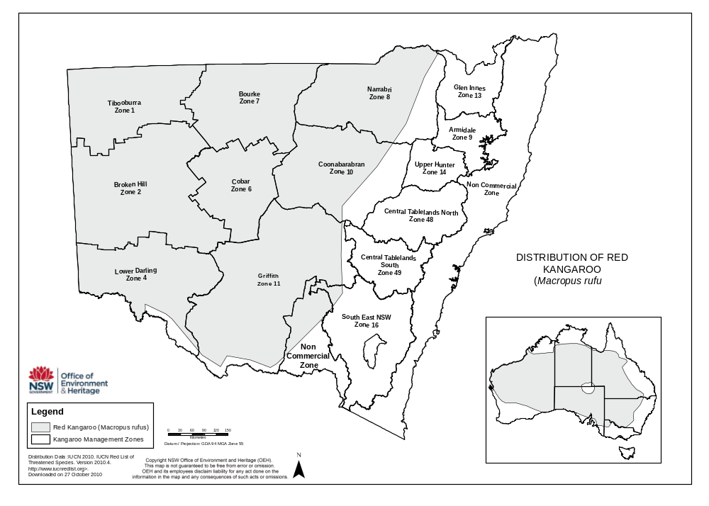
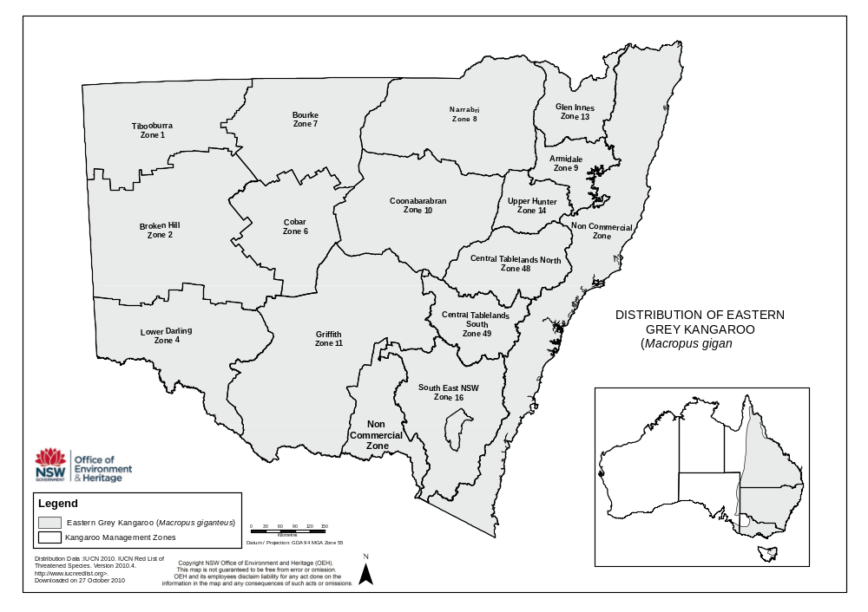
Figure 4: Distribution of eastern grey kangaroo (Macropus giganteus)

Figure 5: Distribution of western grey kangaroo (Macropus fuliginosus)
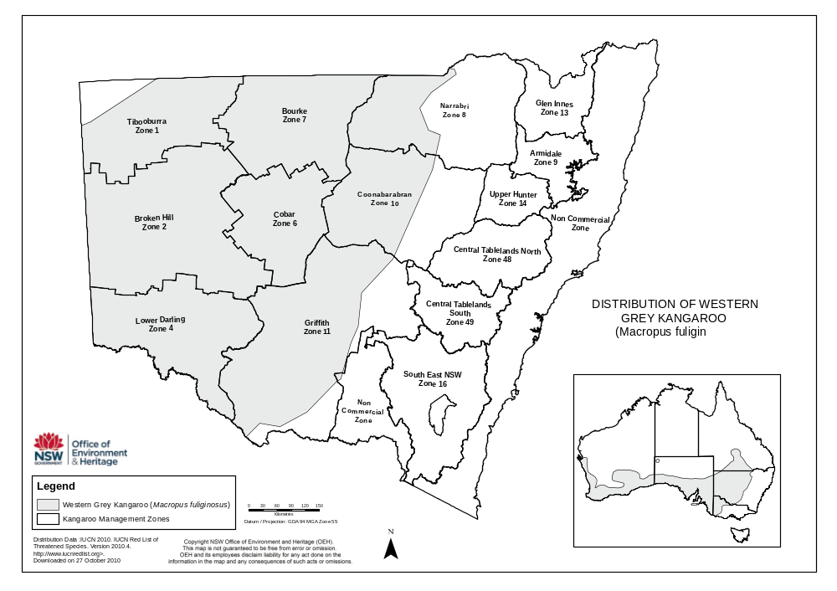
Figure 6: Distribution of wallaroo (Macropus robustus)
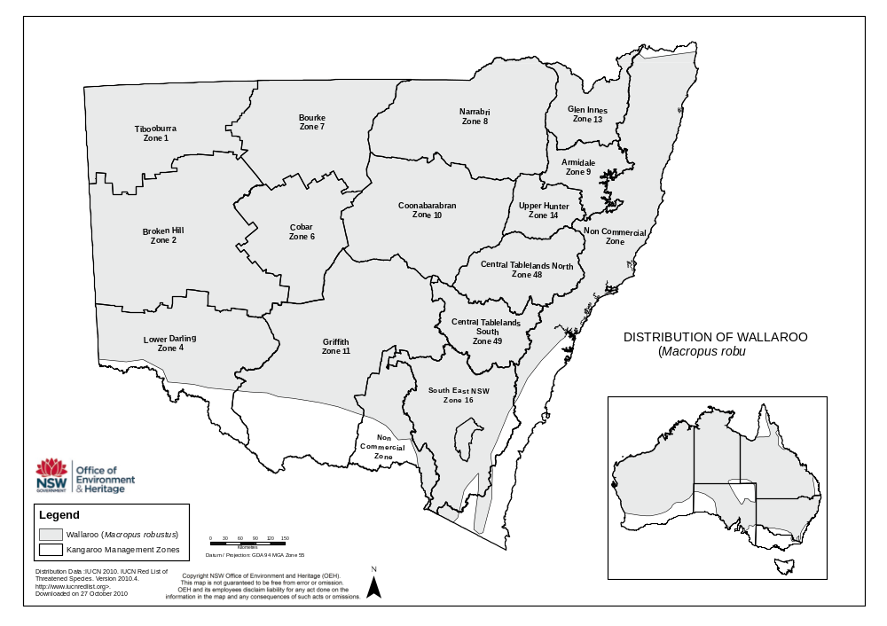

3.3. Conservation Status
The conservation status of the commercially harvested kangaroo species in NSW reflects their abundance and thus their utilisation. No commercially harvested kangaroo species in NSW is listed as a threatened or endangered species under either State or Commonwealth legislation (Table 1). In addition, the International Union for Conservation of Nature and Natural Resources (IUCN) Red List of Threatened Species identifies all of the kangaroo species subject to commercial harvesting in NSW as lower risk, in the sub-category of least concern, which encompasses species that do not qualify for the conservation dependent and near threatened sub-categories (Table 1).
The Convention on International Trade in Endangered Species of Wild Fauna and Flora (CITES) is an international agreement between governments – including the Government of Australia – that aims to ensure international trade in wild animals and plants does not threaten their survival. CITES accords varying degrees of protection to more than 30,000 species of animals and plants, which are listed in the three CITES Appendixes. None of the kangaroo species commercially harvested in NSW is listed in the CITES Appendices (Table 1).
Table 1: The New South Wales, Commonwealth, IUCN and CITES conservation status of the kangaroo species to which this plan relates
Species | NSW | Commonwealth | IUCN | CITES
Red kangaroo | Common | Not listed | Lower Risk | Not listed
Eastern grey kangaroo | Common | Not listed | Lower Risk | Not listed
Western grey kangaroo | Common | Not listed | Lower Risk | Not listed
Wallaroo | Common | Not listed | Lower Risk | Not listed

3.4. Threats, issues and assessment of impacts
In the context of commercial kangaroo harvesting in NSW: threats to the conservation status of harvested kangaroo species are limited; issues relating to the conservation and harvesting of kangaroos are well understood; and assessments of the impacts of harvesting on kangaroos, as well as other species, habitats and ecosystems, are comprehensive.

3.4.1. Threats and issues pertinent to the conservation status of kangaroos
The conservation status of kangaroos in NSW has the potential to be threatened by a range of environmental and anthropogenic factors. Many of these potential threats – from climate change, drought and flood to disease and predation – are ecosystem and environmental processes beyond the control of OEH. Nevertheless, as evidenced by the scientific literature, these processes are not considered a threat to the conservation status of kangaroos (Table 2).
Potential anthropogenic threats to the conservation status of kangaroos principally arise from the commercial harvest. However, in 30 years of commercial harvesting, viable populations of the harvested kangaroo species have been maintained across their natural range and, moreover, the distributional ranges of eastern and western grey kangaroos have expanded. Accordingly, commercial harvesting is not considered a threat to the genetic integrity or conservation status of kangaroos in NSW (Table 2). However, to ensure the commercial kangaroo harvest in NSW remains sustainable and does not in the future jeopardise the viability of kangaroo populations across their range, OEH enacts a range of management controls, including:
- Undertaking regular and ongoing monitoring of kangaroo populations. The strictly standardised survey techniques employed in NSW for the broad-scale monitoring and estimating of kangaroo populations are widely regarded as best practice, both in Australia and overseas (Caughley et al. 1976; Caughley & Grigg 1981; Anderson & Southwell 1995; Southwell et al. 1995; Pople 2004; Pople et al. 2006; Pople 2008). Indirect monitoring is also undertaken via harvest statistics, but is currently used only to supplement direct monitoring from aerial surveys. Predictive models using harvest statistics, rainfall and other data are not yet sufficiently advanced to replace direct monitoring of populations (Pople et al. 2010)
- Managing the commercial harvest using a proportional harvesting strategy based on regular estimates of abundance. Proportional harvesting strategies have been well studied and are considered safe and efficient for fluctuating populations (Caughley 1987a; Engen et al. 1997). Moreover, the NSW program of regularly monitoring and estimating abundance allows for any other mortality agents acting on kangaroo populations to be accounted for in the setting of annual commercial harvest quotas (e.g. animals lost through drought, disease, or road kill).
- Using conservative and up to date species correction factors. OEH employs correction factors in estimating kangaroo abundance from aerial survey data that are generally regarded as cautious. In addition, OEH works collaboratively with universities to ensure correction factors applied remain appropriate. For example, OEH and the University of New England conducted a three-year research project (1998-2000) examining fixed-wing aerial surveys. As a result of this research, OEH has since 2001 implemented new bio-regional correction factors for grey and red kangaroos, implemented revised proportions of eastern grey and western grey kangaroos and implemented a new data analysis protocol.
- Setting commercial harvest quotas at levels that are considered ecologically sustainable for kangaroo populations. Commercial harvest quotas set at 15% of the population estimate for eastern grey kangaroos, western grey kangaroos, wallaroos and 17% of the population estimate for red kangaroos are not only regarded as ecologically sustainable in the scientific literature (e.g. Caughley 1987a; Hacker et al. 2003, 2004), but are demonstrably sustainable. Additional protection for low populations is achieved by reducing or suspending the harvest if populations fall below thresholds based on historical fluctuations (Pople 2008).
- Providing refuge habitat. In NSW kangaroos cannot be commercially harvested in conservation reserves, a total area in excess of four million hectares or approximately 6.3 percent of the commercial harvest zones. In addition, the commercial kangaroo harvest is patchy within Kangaroo Management Zones and individual properties, leaving many other areas of unharvested or refuge habitat (Tenhumberg et al. 2004).

3.4.2. Assessment of the impacts of commercial kangaroo harvest on other species, habitats and ecosystems
Impacts on species, habitats and ecosystems resulting from actions detailed within this management plan are unlikely to be significant, and in many instances are expected to be positive (Table 3).
Table 2: Threats and issues pertinent to the conservation status of kangaroos
Threats | Comments | Selected References*
Drought | Rainfall via its impact on plant productivity is the single most important factor impacting on kangaroo populations and droughts can greatly reduce kangaroo numbers. However, kangaroos are well adapted to a dynamic environment and populations recover quickly after drought-driven population crashes, even with continued harvesting. Therefore drought is not considered a threat to the conservation status of kangaroos. | Bayliss 1987; Cairns & Grigg 1993; Cairns et al. 2000; Caughley et al. 1985; McCarthy 1996; Pople 2003; Pople et al. 2010; Robertson 1986; Dawson et al. 2007; Underhill et al. 2007; Fensham & Fairfax 2008
Disease | A range of parasites and pathogens affect kangaroo populations, including cystic hydatid disease, Cryptospiridium, Ovine Johnes Disease, Toxoplasmosis and Herpes. Effects on individual kangaroos range from little impact to severe clinical disease and mortality. Epidemics have caused significant short-term reductions in kangaroo numbers in particular areas; however, these populations have recovered rapidly. Diseases are not considered important agents of mortality in kangaroos at the population level in the long-term and therefore do not pose a threat to the conservation status of kangaroos. | Caughley 1987a; Gilroy et al. 1999; Kirkpatrick 1985; Pople & Grigg 1999; Speare et al. 1989; Banks et al. 2006; Barnes et al. 2007; Power et al. 2005; Ryan et al. 2008; Power et al. 2009; Cleland et al. 2010; Banazis et al. 2010; Parameswaran et al. 2009; Smith et al. 2008; Garnick et al. 2009
Flood | Flooding has been found to affect the short-term distribution and abundance of kangaroos and has been associated with occasional localised epizootics. Flooding is not considered a threat to the conservation status of kangaroos. | Choquenot 1991; Clancy et al. 1990
Habitat loss and modification | The three largest species of kangaroos have benefited significantly from habitat modification, with numbers increasing and ranges extending due principally to the expansion of grasslands. Conversely, kangaroo numbers have generally declined where there is intensive agriculture, urbanisation or extensive clearing. However, despite more than 200 years of heavy exploitation and clearing of the land the larger kangaroos have maintained their populations or increased in abundance and range; accordingly, habitat loss and modification is not considered a threat to the conservation status of kangaroos. | Calaby & Grigg 1989; Dawson et al. 2004; Pople et al. 2010; Short & Grigg 1982
Climate change | Impacts on kangaroos from climate change are difficult to predict but are likely to be negative. Effects on individuals include changes to forage composition, seasonal events, fecundity, survival and behaviour, while effects on populations include changing species abundance, distribution, and genetics. | Ritchie & Bolitho 2008; Dunlop & Brown 2008; Jonzen et al. 2010
Harvesting – general | In 30 years of managed harvest viable populations of the harvested kangaroo species have been maintained across their natural range. Furthermore, the distributional ranges of eastern and western grey kangaroos have expanded. Harvesting is not considered a threat to the conservation status of kangaroos. | Cairns & Coombs 1992; Calaby & Grigg 1989; Dawson et al. 2004; Grigg & Pople 2001; Pople et al. 2007; Viggers & Hearn 2005
Harvesting – genetic impacts | Harvesting, especially non-random or selective harvesting, has the potential to alter the genetic structure and genetic diversity of a population. However, there is no theoretical, empirical or modelled evidence of genetic impacts at current levels of kangaroo harvesting. Therefore harvesting is not considered a threat to the genetic integrity or conservation status of kangaroos. | Clegg et al. 1998; Hacker et al. 2003, 2004; Hacker & McLeod 2003; Hale 2001, 2004; Tenhumberg et al. 2002, 2004; Zenger et al. 2003; Neaves et al. 2009, 2010; Allendorf et al. 2008; Mysterud 2011
Predation | In some circumstances dingoes (Canis lupus dingo) have been shown to limit kangaroo populations, and there is increasing evidence for this species having a regulatory effect. Other predators such as foxes (Vulpes vulpes) and wedge-tailed eagle (Aquila audax) do not appear to exert much influence on the harvested species of kangaroo. Predation is not considered a threat to the conservation status of kangaroos. | Banks et al. 2000; Caughley et al. 1980; Corbert & Newsome 1987; Jarman & Denny 1976; Pople & Page 2001; Thompson 1992; Letnic & Koch 2010; Fillios et al. 2010

Table 3: Impacts of the commercial kangaroo harvest on other species, habitat and ecosystems
Potential Impacts | Comments | Selected References*
Reduction in soil quality and land stability | There is unlikely to be a reduction in soil quality or land stability as a consequence of the commercial kangaroo harvest as harvesters generally operate on already-formed tracks. Moreover, kangaroo harvest off cuts have been shown to contribute to soil nutrient retention and cycling, thereby improving soil quality. | Wilson & Read 2003
Detrimental effects on water bodies, watercourses, wetlands and natural drainage systems | There is no evidence that suggests the commercial kangaroo harvest will have detrimental effects on water bodies, watercourses, wetlands and natural drainage systems.
Vegetation clearing or modification | No vegetation is likely to be cleared or modified as a consequence of the commercial harvest. The commercial harvest may however provide indirect benefits to vegetation by potentially contributing to an integrated approach to reducing total grazing pressure or facilitating the retention of vegetation that provides habitat for kangaroos by private landholders. | Fisher et al. 2004; Grigg 1988, 1995
Detrimental effects on threatened flora species, populations, or their habitats | There is no evidence that the commercial kangaroo harvest has a detrimental effect on threatened flora species, populations, or their habitats.
Endangering, displacing or disturbing native fauna, or creating a barrier to their movement | Native fauna is unlikely to be endangered, displaced or disturbed as a consequence of the commercial kangaroo harvest. The commercial harvest is, moreover, unlikely to create a barrier to the movement of native fauna. Kangaroo harvest off cuts are however utilised by birds of prey thereby benefiting these species. | Read & Wilson 2004
Detrimental effects on threatened fauna species, populations, or their habitats | There is no evidence that the commercial kangaroo harvest has a detrimental effect on threatened fauna species, populations, or their habitats. There may be indirect effects on threatened fauna species and/or populations as a consequence of the commercial kangaroo harvest, however such effects are not likely to be significant (see section on introduced predators below).
Detrimental impacts on ecological communities of conservation significance | Ecological communities of conservation significance are unlikely to be impacted by the commercial kangaroo harvest.
Positive effects on introduced predators | Kangaroo harvest off cuts are utilised by introduced predators, particularly foxes (Vulpes vulpes) and may sustain populations of these predators during periods of low prey availability. Maintenance of artificially high predator populations may in turn threaten prey populations, including endangered taxa. However, given that many harvesters presently bury harvest off cuts and that harvest off cuts are widely and randomly dispersed across the landscape, it is unlikely that the commercial kangaroo harvest will have a significant positive effect on populations of introduced predators. | Kay et al. 2000; Read & Wilson 2004; Saunders et al. 1995
Positive effects on introduced herbivores | The commercial kangaroo harvest, by reducing kangaroo populations and thus competition, may allow populations of introduced herbivores such as goat (Capra hircus) and rabbit (Oryctolagus cuniculus) to increase. However, the limited magnitude of the reduction in kangaroo numbers coupled with the ongoing and extensive pest animal control programs undertaken in NSW ensure that the commercial kangaroo harvest is unlikely to have a significant positive effect on populations of introduced herbivores.
* Where applicable and/or available

4. GOAL AND AIMS

4.1. Goal
The overarching goal of the New South Wales Commercial Kangaroo Harvest Management Plan 2012 – 2016 is:
To maintain viable populations of kangaroos throughout their ranges in accordance with the principles of ecologically sustainable development.
The principles of ecologically sustainable development are defined in the EPBC Act.
In order to attain its overarching goal, this management plan has seven aims, each of which encompasses a particular facet of kangaroo management. When the aims are combined, they set strategic directions for the management of the commercial kangaroo harvest in NSW.
Under each aim there are one or more actions detailing both how the aim will be delivered and operational directions for kangaroo management. A range of performance indicators for each action have also been developed so that progress towards achieving the goal and aims of the management plan can be measured.
Throughout the life of this plan, aims will be audited annually against performance indicators, with a major assessment and review at the end of the management plan’s five-year term.

4.2. Aims
The aims of this management plan are:

1. MANAGE COMMERCIAL OPERATORS VIA LICENSING
Manage the utilisation of kangaroo species in accordance with the provisions of the NPW Act and Regulation, NSW Government policies, the National Code of Practice for the Humane Shooting of Kangaroos and Wallabies for Commercial Purposes and this management plan.

2. ENSURE HUMANE TREATMENT OF KANGAROOS
Promote improved animal welfare outcomes and ensure that the commercial harvest of kangaroos under this plan is carried out in accordance with the National Code of Practice for the Humane Shooting of Kangaroos and Wallabies for Commercial Purposes.

3. MONITOR INDUSTRY COMPLIANCE
Monitor the kangaroo industry to ensure compliance with this management plan, licence conditions, the requirements of the NPW Act and Regulation and the National Code of Practice for the Humane Shooting of Kangaroos and Wallabies for Commercial Purposes.

4. MONITOR KANGAROO POPULATIONS
Monitor kangaroo populations and set commercial quotas to ensure kangaroos are utilised in accordance with the goal of the management plan. Direct and indirect monitoring will be undertaken in all areas where kangaroos are commercially utilised.

5. FACILITATE ADAPTIVE MANAGEMENT AND RESEARCH
Promote adaptive management experiments and studies using historical data from kangaroo industry returns and population data to improve our understanding of kangaroos and their interaction with environmental, social and economic systems. Facilitate research into other aspects of kangaroo ecology and/or harvest management as required to fill knowledge gaps.

6. UNDERTAKE PROGRAM REPORTING AND REVIEW
Undertake regular reporting and a final program review in consultation with affected community and stakeholders to ensure management is fully informed and to ensure outcomes remain consistent with the goal of the management plan.

7. PROMOTE COMMUNITY AWARENESS AND PARTICIPATION
Promote greater understanding of the program through informed public and private sector participation in management of the commercial utilisation of kangaroos.

5. MANAGEMENT ACTIONS AND PERFORMANCE INDICATORS

AIM 1: MANAGE COMMERCIAL OPERATORS VIA LICENSING
In order to ensure that viable populations of kangaroos are maintained throughout their ranges, the commercial kangaroo industry in NSW is closely regulated via a range of licensing and tag procedures provided for under the NPW Act and Regulation. The legislative basis for licensing and licensing procedures is described in detail in Section 2.2.

ACTION 1: All relevant activities are licensed in accordance with the applicable New South Wales legislation and OEH policy.
All applications for licences relating to NSW commercial kangaroo industry operations are to be assessed, processed and issued in accordance with the provisions of the NPW Act and Regulation and relevant OEH policy.
Performance indicator:

1.1 All licences across NSW are assessed, processed and issued in accordance with NSW legislation and OEH policy.
A random sample of licences issued will be audited on a quarterly basis to ensure licences are being issued in accordance with the relevant legislation and policy; OEH procedures are being followed correctly; accurate information is being entered into appropriate databases; and licences are being assessed and issued appropriately. This performance indicator is also a measure of success in the training of staff who approve and issue licences.

ACTION 2: Licence conditions are effective and reflect current New South Wales legislation, OEH policy and the New South Wales Commercial Kangaroo Harvest Management Plan 2012 – 2016.
To effectively and efficiently manage commercial kangaroo operations in NSW, licence conditions must be effective and consistent with NSW legislation, OEH policy and the New South Wales Commercial Kangaroo Harvest Management Plan 2012 – 2016. Accordingly, the standard licence conditions for each licence type will be reviewed, and where necessary amended, in response to changes in NSW legislation and/or OEH policy. All proposed amendments to licence conditions will be assessed by OEH's legal representatives prior to implementation and licensees will be advised of changes to their licence conditions in writing.
Performance indicators:

2.1 Licence conditions are reviewed at least annually and where necessary amended.

2.2 Licensees are advised in writing of changes to licence conditions within one month of such changes being approved by the Manager, Kangaroo Management Program.

AIM 2: ENSURE HUMANE TREATMENT OF KANGAROOS
Animal welfare is of prime concern to OEH. The National Code of Practice for the Humane Shooting of Kangaroos and Wallabies for Commercial Purposes is the current nationally-endorsed animal welfare standard for the commercial harvest of kangaroos. Accordingly, the commercial kangaroo industry is required to comply with this Code. Any approved subsequent code/s will similarly be adopted as the animal welfare standard for the commercial harvest of kangaroos in NSW. Conditions attached to harvester’s licences provide financial disincentives for shooting other than in accordance with the Code. Similar conditions apply to fauna dealer’s licences.

ACTION 3: OEH will work with the New South Wales Firearms Safety and Training Council Ltd to ensure that all harvesters are competent to achieve the standards set out in the National Code of Practice for the Humane Shooting of Kangaroos and Wallabies for Commercial Purposes.
In order to ensure that the kangaroo harvest is humane, kangaroo harvesters are required to demonstrate their competency in relation to the National Code of Practice for the Humane Shooting of Kangaroos and Wallabies for Commercial Purposes prior to obtaining their licences. The current accreditation program is conducted by the New South Wales Firearms Safety and Training Council Ltd and includes both a written test and a shooting test. Harvesters must renew their accreditation every five years and cannot renew their harvester’s licences if their accreditation has expired.
Performance indicators:
  - All successful applicants for harvester’s licences have completed the approved accreditation and their accreditation is current.
  - During the life of this plan, the content of the accreditation course will be reviewed and revised if necessary.

ACTION 4: OEH staff will monitor compliance with the National Code of Practice for the Humane Shooting of Kangaroos and Wallabies for Commercial Purposes by commercial kangaroo industry operators.
OEH authorised officers undertake both regular unannounced and opportunistic inspections of kangaroos taken by licensed harvesters and all premises registered by licensed fauna dealers. Memoranda of Understanding are in place between OEH and the NSW Food Authority, and OEH and the Australian Quarantine and Inspection Service (AQIS) in relation to reporting breaches of conditions relating to animal welfare. These agreements significantly increase the detection of kangaroo carcases that have not been taken in accordance with licence conditions. OEH does not tolerate breaches of the Code of Practice, and where kangaroos have been found to be taken other than in accordance with the Code, Penalty Notices are issued or licensees are prosecuted as appropriate. This ‘zero tolerance’ policy of animal welfare breaches demonstrates OEH’s commitment to ensuring that the commercial harvest of kangaroos is humane.
Performance Indicators:
  - All licensees who are found to have breached licence conditions relating to animal welfare are issued with Penalty Notices or are prosecuted as appropriate.
  - During the life of this plan, a selection of harvesters will be audited to determine the level of compliance with the Code of Practice in the field.

ACTION 5: OEH will facilitate research into improving animal welfare outcomes associated with the commercial harvest of kangaroos.
OEH will work with external research organisations to identify and investigate animal welfare issues relevant to the commercial harvest of kangaroos. Research may include aspects of the biology and ecology of kangaroos as they relate to the commercial harvest, or harvest techniques. Contributions by OEH may include funding and/or in-kind support such as the provision of harvest data.
Performance indicator:

5.1 Issues associated with the animal welfare aspects of the commercial harvest are identified and research proposals are sought from universities and other research institutions during the life of this plan.

AIM 3: MONITOR INDUSTRY COMPLIANCE
Monitoring commercial kangaroo industry compliance with the provisions of NSW legislation, OEH policy, the goal and aims of the New South Wales Commercial Kangaroo Harvest Management Plan 2012 - 2016 and licence conditions is essential to effectively maintaining viable populations of kangaroos throughout their ranges and to ensuring public confidence in the management of kangaroos in NSW.

ACTION 6: OEH staff will undertake both regular and opportunistic monitoring of compliance by commercial kangaroo industry operators.
In order to assess industry compliance, authorised OEH officers will, on both a regular and opportunistic basis, inspect kangaroos taken by licensed harvesters and all premises registered by licensed fauna dealers. The inspecting officers will check to ensure the kangaroos have been taken in accordance with the NPW Act and Regulation, the New South Wales Commercial Kangaroo Harvest Management Plan 2012 – 2016 and licence conditions. Assessments to ensure compliance with the current National Code of Practice for the Humane Shooting of Kangaroos and Wallabies for Commercial Purposes will be a priority.
In addition, OEH has a Memorandum of Understanding (MOU) with the New South Wales Food Authority in relation to the inspection of premises used to store kangaroo carcases. Under the terms of this MOU, issues pertinent to OEH will continue to be examined by New South Wales Food Authority officers during their inspections of harvesters and registered premises, and referred to OEH for investigation if required. Authorised OEH officers will reciprocate. A similar agreement is in place between OEH and AQIS in relation to inspection of carcases at processing plants registered for the export of meat products for human consumption. Under the agreement, information pertaining to possible breaches of OEH licence conditions are reported by AQIS and where appropriate, further investigated by OEH.
Performance indicators:

6.1 On receipt of harvester’s licence applications, the authorised OEH officer assessing the applications will ensure that applicants have both a valid NSW harvester accreditation and a valid Firearms Licence.

6.2 All chiller premises are inspected every three months on average during the life of this plan by OEH staff and/or staff of the New South Wales Food Authority to ensure compliance with NSW legislation and licence conditions. Where a chiller premises has not been registered for the full calendar year, inspections will be required on a pro rata basis. Chiller premises that are registered but known to be non-operational may not require regular inspection.

6.3 All kangaroo processing works in NSW are inspected every three months on average during the life of this plan by OEH staff and/or staff of the New South Wales Food Authority to ensure compliance with NSW legislation and licence conditions.

6.4 During the life of this plan, harvesters’ vehicles loaded with kangaroo carcasses are inspected opportunistically to ensure compliance with NSW legislation and licence conditions and the results of these inspections are documented.

ACTION 7: Activities not in accordance with the New South Wales Commercial Kangaroo Harvest Management Plan 2012 – 2016 and NSW legislation will be investigated and where an offence has been committed and it is appropriate, prosecuted.
Investigation and prosecution of activities not in accordance with the New South Wales Commercial Kangaroo Harvest Management Plan 2012 – 2016 and NSW legislation is essential for delivery of the plan and for maintaining public, industry and stakeholder confidence in the effectiveness of the plan as a mechanism for maintaining the viability of kangaroo populations, and thus the commercial kangaroo industry.
Performance indicator:

7.1 Reports of unlicensed activities and activities in breach of licence conditions are investigated to the fullest extent possible, and where sufficient evidence is available offenders are issued with Penalty Infringement Notices or prosecuted as appropriate.

ACTION 8: The accuracy of industry returns will be continually monitored during the life of this plan.
It is a licence condition that commercial kangaroo industry operators submit regular returns to OEH. The data obtained from these returns is essential for monitoring whether industry is harvesting kangaroos within approved quotas and for reporting to the Commonwealth Government, industry and the public. In addition, the data from industry returns is utilised in indirect monitoring of kangaroo populations.
Performance indicator:

8.1 During the life of this plan, all incoming industry returns are scrutinised and discrepancies are investigated and resolved.
Auditing industry returns encompasses manual assessment of returns, application of the customised licensing database utilised by OEH which includes numerous validation rules that assist in ensuring the integrity of data, and extensive verbal and written communication between OEH staff and industry operators.

ACTION 9: A compliance database will be maintained to support investigations, inspections and audits.
A compliance database for use in kangaroo management investigations, inspections and audits will be maintained for use by staff involved with kangaroo management. The database facilitates compliance reporting to the Commonwealth Government and other stakeholders and also easy access to information for relevant authorised OEH officers.
Performance indicator:

9.1 A compliance database is maintained.
Relevant compliance information stored in the customised database includes reports of alleged breaches of the NPW Act and/or licence conditions, investigation activities undertaken and outcomes of investigations. Data input is accurate and timely.

AIM 4: MONITOR KANGAROO POPULATIONS
Monitoring commercially harvested kangaroo populations, both directly and indirectly, is essential to effectively maintaining viable populations of kangaroos throughout their ranges.
The four currently commercially utilised kangaroo taxa – M. rufus, M. giganteus, M. fuliginosus, and M. robustus robustus – are widespread and abundant in NSW. The 2010 population estimate for these kangaroo species in commercial Kangaroo Management Zones (KMZs) totalled approximately 8.5 million. M. robustus erubescens has not been monitored since 2002, at which time the species population was estimated to be approximately 12,000.
A great deal is known about the biology of kangaroos including their habitats, distributions (Section 3), diets and reproduction, and this knowledge is continually improving. In particular, the reproductive biology of kangaroos has been researched extensively. While there are variations between the kangaroo species (e.g. gestation period, lactation period and interval between young), these are relatively well understood and accounted for in the various quotas set for each species. In addition, there is abundant information from direct (periodic) and indirect (continuous both temporally and spatially) monitoring of kangaroos.
The commercial take of kangaroos in KMZs is patchy. Even within a single property the rate of take can vary from zero (un-shot areas) to areas heavily utilised. Kangaroos may move between areas of different utilisation rates. In heavily wooded areas the take can be restricted to the established property tracks only, resulting in use of relatively thin strips of land through the property. In other areas the entire property may be accessible and utilised. Generally commercial utilisation of kangaroos will be biased towards larger animals and therefore males. Kangaroo mortality during drought is also male biased, and female biased populations have been observed in un-shot areas. Kangaroos are polygamous and females will mate with available males. In a female biased population (due to commercial use), with favourable seasonal conditions, almost all adult females will have pouch young.
Results of aerial surveys since the mid-1980s show that kangaroo populations fluctuate primarily in response to seasonal conditions. However, epidemic kangaroo mortalities have been recorded, usually following flooding rain. Reports based on aerial surveys suggest significant short-term reductions in populations, greater than 50%, have occurred in some areas.
As illustrated in Section 3 of this plan, a wide range of literature relating to kangaroos and their management is currently available. Of particular interest is a comprehensive review prepared for the Commonwealth Government titled Commercial Harvesting of Kangaroos in Australia. This review is available on the Commonwealth Department of Sustainability, Environment, Water, Population and Communities (SEWPaC) website (www.environment.gov.au/biodiversity/trade-use/wild-harvest/kangaroo/harvesting/index.html) and encompasses topics including the biology of the harvested kangaroo species, the effects of harvesting on kangaroo populations, animal welfare issues and the conservation status of the harvested kangaroo species. A review of recent scientific literature relevant to the commercial harvest has been prepared (Herbert & Elzer 2011) and is available on the Kangaroo Management Program’s webpage.

ACTION 10: Population surveys will be conducted annually for the western plains and three yearly for tableland zones and other areas that require helicopter surveys.
Kangaroo population estimates obtained from surveys (direct monitoring) will be used as the basis of setting commercial quotas following the procedures set out in this management plan.
Fixed-wing aircraft are used across the western plains of NSW to annually survey kangaroo populations. Survey lines have been established at regular intervals across this region and the same lines are surveyed at the same time every year to allow comparison of results between years.
In the tablelands areas, much of the terrain is too steep to be safely surveyed using fixed-wing aircraft so helicopters are used instead. Risk analysis indicates that helicopter surveys undertaken every three years provide an acceptable balance between survey intensity and frequency (Pople 2003; Pople et al. 2003; Pople et al. 2006). Survey frequencies shorter than three years are prohibitively expensive, and longer than three years increase the risk to kangaroo populations.
Full details of survey techniques and data analysis protocols are contained in separate documents provided to the Commonwealth, and are available to the public via the Kangaroo Management Program web page.
For the four species currently harvested commercially – M. rufus, M. giganteus, M. fuliginosus, and M. robustus robustus – the quota will be adjusted based on the most recent population estimate and will therefore account for all kangaroo mortalities, including those unrelated to commercial use.
A commercial harvest quota for M. robustus erubescens will only be set after direct monitoring of this population in the Barrier Ranges district.
Performance indicators:

10.1 Kangaroo population estimates are obtained using standard survey methodology throughout the life of this plan.
There are three standard survey techniques that may be employed for direct monitoring of kangaroo populations.
- Broad-scale aerial surveys using fixed-wing aircraft (fixed strip-width transect survey methodologies). This technique is used to obtain annual population estimates in the western areas of the NSW commercial zone.
- Medium/small-scale surveys using a helicopter (line transect survey methodology). This technique is used primarily in areas not suitable for fixed-wing surveys, e.g. South East NSW, Central and Northern Tablelands. Surveys will be conducted at a frequency of at least once every three years while a commercial quota is in force.
- Small-scale surveys conducted on foot (line transect survey methodology). This technique is rarely employed in this context due to the high associated costs.

10.2 Ground surveys are conducted as required to verify the ratio of eastern grey kangaroos to western grey kangaroos in areas where both species occur.
Ground surveys utilising the line transect survey methodology are used to establish a ratio between the two species, as M. giganteus and M. fuliginosus cannot be distinguished from the air. There is currently no evidence the ratio of these species changes significantly in a short period of time, and therefore frequent surveys are not required and may not be required during the life of this plan. Harvest data will be monitored and ground surveys will be initiated if a significant change in the ratio is indicated.

ACTION 11: Commercial kangaroo harvest quotas will be set in accordance with the provisions of the New South Wales Commercial Kangaroo Harvest Management Plan 2012 – 2016.
The commercial quota for a species is the maximum number that can be utilised commercially in a calendar year. Quotas will be set for each commercially harvested kangaroo species for which current population estimates are available in specific Kangaroo Management Zones (KMZs) (Figure 1 illustrates NSW KMZs). The Commonwealth Government will be advised of the quotas prior to implementation. Any changes to the commercial KMZ boundaries will be advertised on the NSW Kangaroo Management Program web page and described in the quota report to the Commonwealth.
Each occupier's licence for the commercial use of kangaroos specifies the number of each species that can be taken. When the annual quota for a species has been reached in a KMZ, no additional occupier's licences will be issued allowing commercial utilisation of that species in that KMZ until the following year.
Unless undertaken as part of an approved adaptive management experiment (see Action 16), commercial quotas will be set at 15 percent of the population estimate for eastern grey kangaroos, western grey kangaroos and wallaroos and 17 percent of the population estimate for red kangaroos. Not all kangaroo species are harvested in each NSW KMZ. It is important to note that the most recent scientific information available is considered when determining annual quotas and that analysis of this information may result in quotas being decreased in order to maintain the viability of kangaroo populations.
Based on kangaroo population dynamics, quotas set at 15 to 17 percent are considered sustainable in the long-term. Kangaroo populations are expected to continue to fluctuate primarily in response to seasonal conditions, and the quota does not seek to achieve a specific density of kangaroos.
Performance indicators:

11.1 All commercial kangaroo harvest quotas are set in accordance with the provisions of the New South Wales Commercial Kangaroo Harvest Management Plan 2012 – 2016 throughout the life of the plan.

11.2 The Commonwealth Government is advised of commercial harvest quotas for the following calendar year by 30 November.
The Quota Report will contain the following information:
- population estimates for each species in each zone and method of survey used
- quotas calculated as a proportion of population estimate as per the approved Commercial Kangaroo Harvest Management Plan (including Special Quota)
- any proposed changes to quotas
- any new commercial zones and justification based on survey
- charts showing trends in population/quota/take.

11.3 If Commonwealth approval is required for quotas set above the rates specified in the plan as part of an adaptive management experiment, such approval is obtained before the additional quota is implemented.

11.4 The Quota Report is made available to the public via the Kangaroo Management Program web page.

ACTION 12: If kangaroo populations decline to specific trigger points, the commercial harvest of particular species in particular zones will be reduced or suspended.
Kangaroo populations fluctuate in response to changes in seasonal conditions. Populations change more quickly and more dramatically in environments where rainfall is erratic, such as in the Far West of NSW. In more temperate areas, such as the Northern Tablelands, populations change more slowly, and do not vary as much from the average.
This management plan aims to allow kangaroo populations to change according to seasonal conditions. Calculating trigger points based on long-term average populations or densities, and standard deviations, recognises these environmental differences. ‘Standard deviation’ is a statistical measure of how much the population changes relative to its average – in erratic environments, the population changes much more and the standard deviation is larger than in environments that are more stable. This means that the ‘standard deviation’ is different for each species in each zone. The standard deviations will be recalculated after each survey to ensure all available information is utilised. Appendix A provides additional information on the use of population thresholds in harvest management.
Performance indicators:

12.1 Commercial harvest quotas are reduced if population estimates fall below 1.5 standard deviations of the long-term average density, or suspended if population estimates fall below two standard deviations of the long-term average.
If aerial survey results indicate a population has fallen below the long term average density for that species in that zone, the commercial quota will be reduced or suspended for the following calendar year. Where the harvest is suspended, any licences current at that time will be allowed to continue until their expiry, but no new licences authorising the harvest of that species in that zone will be issued. The suspension will remain in place until aerial surveys indicate populations have increased.
Reduction in quota – when populations are below the long-term average by between 1.5 and two standard deviations.
- The annual quota for the following calendar year (commencing January, year 1) will be calculated at ten percent of the population estimate for that species in that zone.
- If the next aerial survey indicates populations have increased to less than 1.5 standard deviations below the average, or are above average, the commercial quota will be calculated at 15 or 17 percent of the new estimate for the following calendar year (January, year 2).
- However, if the survey indicates populations have further declined and are more than two standard deviations below the average, the commercial quota will immediately be suspended.
Suspension of quota – when populations are more than two standard deviations below the long-term average density.
- There will be no annual quota for the following calendar year (commencing January, year 1) for that species in that zone.
- If the next aerial survey indicates populations have increased to between 1.5 and two standard deviations below the average, a commercial quota will be set at ten percent for that species in that zone for the following year (commencing January, year 2).
- If the next aerial survey indicates populations have increased to less than 1.5 standard deviations below the average, or are above average, the commercial quota will be calculated at 15 or 17 percent of the new estimate for the following calendar year (commencing January, year 2).
- However, if the survey indicates that populations have not increased or have further declined, the harvest suspension will remain in place and no commercial quota will be set for that species in that zone for the following calendar year (commencing January, year 2).

ACTION 13: Special kangaroo harvest quotas will be set in accordance with the provisions of the New South Wales Commercial Kangaroo Harvest Management Plan 2012 – 2016.
A special quota for commercial KMZs will be set annually at a maximum of five percent of the population estimate of each kangaroo species in any one zone, and a maximum of 1.5 percent of the population of each species across all zones.
The sole purpose of special quota allocations is to provide for commercial utilisation of kangaroos that would be shot and left in the field under the normal non-commercial licensing system. The special quota will therefore minimise the number of kangaroos shot under non-commercial licences. The special quota can only be considered for release when the commercial quota for a particular KMZ has been fully issued, and will not be allocated in zones where the commercial harvest is reduced or suspended due to low populations.
The use of special quota will depend on one or more of the following:
- A commercial quota was set at the usual proportion for that species in that zone (ie. Not reduced or suspended due to low populations)
- climatic trends and local conditions – for example, rainfall in the lowest five percent of historical records over the previous twelve months
- Western Lands de-stocking orders
- kangaroo population trends.
OEH will make the decision whether to make the special quota available at any particular time following consultation with the Kangaroo Management Advisory Panel and consideration of these factors.
Special quota allocations and the use of the special quota will be reported to the Commonwealth in the Quota Report and Annual Report.
Performance indicator:
Special kangaroo harvest quotas are set and utilised in accordance with the provisions of the New South Wales Commercial Kangaroo Harvest Management Plan 2012 – 2016.

ACTION 14: Kangaroo populations will continually be monitored indirectly throughout the life of this plan.
Indirect data on kangaroo populations will be obtained continuously throughout the life of this plan from commercial kangaroo industry returns. Licensee returns detail the number of each species taken and data on average carcase weights, sex and location of take, depending on the type of licence.
Ongoing monitoring of licence returns by OEH will identify significant changes in the average weights of harvested kangaroos, which, for example, can provide an indication of population health.
Performance indicators:

14.1 Sudden, sustained or acute changes in the average weights of harvested kangaroos, as ascertained from licensee returns, are investigated to determine where practicable the cause of the change.

14.2 Average carcase weights for each species (male and female separately) will be analysed for each month. If the average for any species in any zone falls below the long-term average (at least the last ten years) by more than one standard deviation for three successive months, OEH will undertake investigations to determine where practicable the cause of the change. For example, OEH may conduct smaller scale aerial population surveys; conduct ground-based population surveys; or autopsy kangaroo carcases if disease is a suspected cause of the change. If OEH considers action is necessary to ensure the sustainability of the kangaroo population, it will reduce or suspend the commercial harvest for that species in that zone.

AIM 5: FACILITATE ADAPTIVE MANAGEMENT AND RESEARCH
Adaptive management experiments and studies using historical data from kangaroo industry returns and population data are essential to improving our understanding of kangaroos and their interaction with environmental, social and economic systems, and thereby effectively maintaining viable populations of kangaroos throughout their ranges. Research into particular aspects of kangaroo ecology or harvest management can also assist in ensuring that the commercial harvest is sustainable in the long term. While there has been a large body of research on the ecology and management of kangaroos, there are information gaps which, when filled, may lead to more effective management of the commercial harvest.

ACTION 15: Historical data relating to the commercial kangaroo harvest in New South Wales will be analysed during the life of this plan to identify trends; this analysis will be considered in future kangaroo management programs.
Previous kangaroo management programs have obtained a wide range of information relating to the commercial harvesting of kangaroos in NSW. This information will be analysed to provide data on trends in kangaroo populations, utilisation rates, average weights and other specific information relating to either the commercial harvest or kangaroo populations generally.
The analysis of historical data relating to the commercial kangaroo harvest in NSW may be undertaken by a range of individuals or organisations including tertiary students, university professionals, consultants or OEH.
Performance indicators:

15.1 Analysis of historical kangaroo harvest and management data is undertaken during the life of this plan.
Data analysis research proposals from external organisations must be accompanied by a project plan that clearly identifies the goals and objectives of the proposed research and outlines performance indicators that enable an assessment of the success (or otherwise) of the research.

15.2 The results of analysis and research using historical kangaroo harvest and management data are published in an appropriate forum.
Consideration of research findings and the results of any analysis are essential in not only the development of future Commercial Kangaroo Harvest Management Plans, but also for facilitating the adaptive management of kangaroo populations, which in turn will aid in maintaining viable populations of kangaroos throughout their ranges. The appropriate forum will vary according to the type of research or analysis. At a minimum, the results of any research undertaken using OEH data should be provided to OEH, and ideally be made available from the Kangaroo Management Program web page.

ACTION 16: Where practicable, experiments will be performed to test deliberate management interventions during the life of this plan.
Under active adaptive management, management activities are conducted as a deliberate experiment. Alternative strategies are viewed as treatments and are implemented through statistically valid experimental design; monitoring is the data-collection step of the experiment. Active adaptive management can establish cause-and-effect relationships between activities and changes in ecological conditions.
All proposals to undertake active adaptive management experiments will be reviewed by the Kangaroo Management Advisory Panel and will be critically assessed by OEH with reference to the following criteria:
- the proponents' awareness of relevant background information
- whether the proposal considers alternative models and hypotheses
- whether the proposal is scientifically rigorous and statistically valid
- whether the proposal incorporates a monitoring program
- that there is substantial evidence that the risk of permanent damage to kangaroo populations is low
- that the proposal is consistent with the goal of the New South Wales Commercial Kangaroo Harvest Management Plan 2007 – 2011 and relevant NSW legislation
- that the proposal includes consideration of how management may be modified to accommodate the new knowledge gathered from the intervention.
All experiments that affect the commercial utilisation of kangaroos must also demonstrate how the experiment provides for reasonable business planning and investment.
Performance indicators:

16.1 All proposals to undertake active adaptive management experiments are reviewed and assessed by OEH in accordance with the criteria outlined in this plan.

16.2 All necessary approvals – including animal care and ethics - are obtained prior to experiments testing deliberate management interventions commence.
In certain situations OEH will seek approval from the Commonwealth Department of Sustainability, Environment, Water, Population and Communities. Experiments requiring such approval may comprise a harvest rate in excess of the harvest rates set out in this plan.

16.3 All adaptive management experiments are continuously monitored and conducted according to approval conditions.
As per the criteria outlined above, all active adaptive management experiment proposals must have monitoring programs incorporated. Monitoring programs must be maintained during the life of the experiment. All monitoring must be conducted in accordance with any conditions imposed with the approval.

16.4 Results of all experiments testing deliberate management interventions are published in an appropriate forum.
The appropriate forum for dissemination will vary according to the type of research and the target audience. However, it is expected that any research conducted as an active adaptive management experiment in accordance with the provisions of this plan will be made available to for the information of the Kangaroo Management Advisory Panel (KMAP – see Aim 6) and OEH for inclusion on the Kangaroo Management Program web page.

ACTION 17: OEH will facilitate research into the ecology and harvest management of kangaroos.
OEH will work with external research organisations to identify and investigate issues relevant to the commercial harvest of kangaroos. Research may include aspects of the biology and ecology of kangaroos as they relate to the commercial harvest, or harvest techniques. Contributions by OEH may include funding and/or in-kind support such as the provision of harvest data.
Performance indicator:

17.1 Issues associated with the ecology of harvested species and the management of the commercial harvest are identified and research proposals are sought from universities and other research institutions during the life of this plan.

AIM 6: UNDERTAKE PROGRAM REPORTING AND REVIEW
Regular program review and concomitant reporting is essential to effectively maintain viable populations of kangaroos throughout their ranges as it ensures management outcomes remain consistent with the goal and aims of the plan and management is fully informed.

ACTION 18: An annual report on the New South Wales Kangaroo Management Plan 2012 – 2016 will be prepared and submitted to the Commonwealth.
An annual report detailing the operation of the New South Wales Commercial Kangaroo Harvest Management Plan 2012 – 2016 for the previous calendar year will be prepared and submitted to the Commonwealth. This report will provide information on the previous year's quotas and harvest rates, any use of special quota and details of research involvement. This report will also identify whether any adaptive management experiments were undertaken and provide details about compliance actions undertaken within the auspices of this plan. Finally, this report will audit plan aims against performance indicators so that progress towards achieving the goal of the management plan can be measured.
Performance indicators

18.1 An annual report on the operation of the New South Wales Commercial Kangaroo Harvest Management Plan 2012 - 2016 for the previous calendar year is submitted to the Commonwealth by end of March of the following year.
The Annual Report will include the following information:
- actual harvest, by zone and species, compared to quota
- any Special Quota utilised
- sex bias and average weights for each species in each zone
- non-commercial cull statistics within the commercial harvest zone
- compliance statistics:
- number of premises inspected
- number of penalty notices issued and reason for issue
- number of alleged offences investigated and outcomes
- number of prosecutions undertaken (offence and outcome)
- any joint surveillance/enforcement activities completed.
- any unusual situations that arose (e.g. flood/disease outbreak; market factors)
- any experiments or research undertaken or sponsored by OEH

18.2 All annual reports prepared during the life of this plan are posted on Kangaroo Management Program web page.

ACTION 19: The review of the New South Wales Commercial Kangaroo Harvest Management Plan 2012 – 2016 will commence no later than twelve months prior to the expiry of this plan.
The review of the New South Wales Commercial Kangaroo Harvest Management Plan 2012 – 2016 will commence no later than twelve months prior to the expiry of this plan in order to assess the success of the plan in achieving its goal. The review will be conducted with the aim of improving on the current plan in the development of subsequent plans.
Performance indicators:

19.1 The schedule of OEH Commercial Kangaroo Harvest Management Plan review activities initiated no later than 12 months prior to the expiry of this plan will include, but is not limited to:
- strategic planning prior to a full review of the program
- compilation of reports including reviews of relevant literature
- public meetings / forums including the KMAP and invited scientists
- public exhibition of new draft program
- KMAP review of public submissions.

19.2 The success of the current plan in achieving its goal is assessed by measuring performance indicators.

19.3 The results of the plan review are presented to the Commonwealth and are placed on Kangaroo Management Program web page.

AIM 7: PROMOTE COMMUNITY AWARENESS AND PARTICIPATION
The public profile of kangaroo management in NSW is high, in part due to the sometimes contentious nature of the commercial harvest, and in part due to the large number of stakeholders involved in the commercial kangaroo industry. Consequently, community awareness of and participation in kangaroo management is considered a key component in the success of the program, and thus the maintenance of viable populations of kangaroos throughout their ranges.

ACTION 20: Members of the Kangaroo Management Advisory Panel will be provided with relevant information and afforded the opportunity to advise OEH on key kangaroo management issues throughout the life of this plan.
The Kangaroo Management Advisory Panel (KMAP), which is convened by OEH, is the main forum through which stakeholder group representatives can raise issues for discussion, as well as communicate their group's positions and interests to Government on a regular basis. The current membership of KMAP encompasses representatives of animal welfare, the kangaroo industry, landholder groups, Aboriginal communities, conservation organisations and government stakeholder groups. Member organisations hold their appointed positions for three-year terms. The function of KMAP is to advise the Chief Executive Officer of OEH on matters pertaining to the implementation and review of the New South Wales Commercial Kangaroo Harvest Management Plan 2012 – 2016. Relevant information is provided to members of KMAP to ensure that they have appropriate information in order to make informed decisions as part of their advisory role.
Performance indicators:

20.1 KMAP is provided with monthly updates on commercial harvest and tag issue throughout the life of this plan.

20.2 KMAP is provided with other relevant information as required or as necessary throughout the life of this plan.

20.3 KMAP meets at least twice per year to review progress of New South Wales Commercial Kangaroo Harvest Management Plan 2012 – 2016 in relation to the goal and aims of the plan.

ACTION 21: Relevant public documents will be made available on the Kangaroo Management Program web page.
The provision of information to members of the public promotes understanding of the New South Wales Commercial Kangaroo Harvest Management Plan 2012 – 2016 and allows members of the community to form better-educated opinions regarding kangaroo management issues.
Performance indicator:

21.1 Throughout the life of this plan the Kangaroo Management Program web page contains the following information as a minimum standard:
- the current and previous Commercial Kangaroo Harvest Management Plans
- monthly tag issue and commercial harvest statistics
- historical harvest statistics
- population survey reports
- current population estimates
- current commercial quotas
- ratified minutes of recent KMAP meetings
- contact information for the Kangaroo Management Section
- current forms for commercial kangaroo licences.
Additional relevant information will be posted on the Kangaroo Management Program web page as available and appropriate.

ACTION 22: Publicly available information will be provided to interested parties on request.
The provision of information assists to promote understanding of the Kangaroo Management Program and helps interested parties to form educated opinions in relation to kangaroo management issues.
Performance indicator:

22.1 Publicly available kangaroo management information is distributed to interested parties as soon as practicable after such a request, in an appropriate format.

ACTION 23: Where appropriate relevant OEH staff will participate in media interviews and prepare media releases.
Participation in media interviews and preparation of media releases can be an effective mechanism for communicating information regarding kangaroo management to a broad audience and moreover improves program transparency and accountability and therefore public confidence.
Performance indicators:

23.1 OEH staff participate in interviews with the media where appropriate.
The Manager Kangaroo Management Section, Director North West Branch and other senior OEH officers participate in appropriate interviews on request from media agencies.

23.2 Media releases are prepared when appropriate for issues of interest to the community such as population surveys and the release of the quota for the next calendar year.

ACTION 24: Relevant information regarding licensing arrangements will be developed as required and distributed to all licensees.
Licensees and operators will be provided with written information relevant to their licensing arrangements to promote voluntary compliance with the licensing framework. Handbooks for kangaroo harvesters and managers of kangaroo chillers will be revised as necessary to ensure information is current.
Performance indicators:

24.1 A copy of the current Handbook for kangaroo harvesters is issued with every new harvester's licence throughout the life of this plan to ensure that licensees are apprised of relevant licensing requirements and responsibilities.

24.2 A copy of the current Handbook for kangaroo chiller managers is issued with every new chiller registration or change in nominated manager to ensure that operators are aware of relevant licensing requirements and responsibilities.

REFERENCES
Anderson DR & Southwell C (1995) ‘Estimates of macropod density from line transect surveys relative to analyst expertise’, Journal of Wildlife Management, 59(4):852-857.
Bailey PT (1971) ‘The red kangaroo, Megaleia rufa (Desmarest), in north-western New South Wales. I. Movements’, CSIRO Wildlife Research 16:11-28.
Bailey PT, Martensz PN & Barker R (1971) ‘The red kangaroo, Megaleia rufa (Desmarest), in north-western New South Wales. II. Food’, CSIRO Wildlife Research 16:29-39.
Banks PB, Newsome AE & Dickman CR (2000), ‘Predation by red foxes limits recruitment in populations of eastern grey kangaroos’, Austral Ecology 25:283-291.
Barker RD (1987) ‘The diet of herbivores in the sheep rangelands’ in G Caughley, N Shepherd & J Short (eds), Kangaroos: their ecology and management in the sheep rangelands of Australia, Cambridge University Press, Cambridge, pp. 69-83.
Bayliss P (1987) ‘Kangaroo dynamics’. In G Caughley, N Shepherd and J Short (eds), Kangaroos: their ecology and management in the sheep rangelands of Australia, Cambridge University Press, Cambridge, pp. 119-134.
Bell HM (1973) ‘The ecology of three macropod marsupial species in an area of open forest and savannah woodland in north Queensland, Australia’, Mammalia 37:527-544.
Bilton AD & Croft DB (2004) ‘Lifetime reproductive success in a population of female red kangaroos Macropus rufus in the sheep rangelands of western New South Wales: Environmental effects and population dymanics’, Australian Mammalogy 26:45-60.
Cairns SC & Coombs MT (1992) The monitoring of the distributions of commercially harvested species of macropod in New South Wales, unpublished report to the Australian National Parks and Wildlife Service.
Cairns SC & Grigg GC (1993) ‘Population dynamics of red kangaroos (Macropus rufus) in relation to rainfall in the South Australian pastoral zone’, Journal of Applied Ecology 30:444-458.
Cairns SC, Grigg GC, Beard LA, Pople AR & Alexander P (2000) ‘Western grey kangaroos (Macropus fuliginosus) in the South Australian pastoral zone: populations at the edge of their range’, Wildlife Research 27:309-318.
Calaby JH (1966) Mammals of the upper Richmond and Clarence Rivers, NSW, CSIRO Division of Wildlife Research Technical Paper, no. 10, pp. 1-55.
Calaby JH & Grigg GC (1989) ‘Changes in macropodoid communities and populations in the past 200 years, and the future’, in G Grigg, P Jarman & I Hume (eds), Kangaroos, wallabies and rat-kangaroos, Surrey Beatty & Sons, Sydney, pp. 813-820.
Caughley G (1964) ‘Density and dispersion of two species of kangaroo in relation to habitat’, Australian Journal of Zoology 12:238-249.
Caughley G (1976) ‘Wildlife management and the dynamics of ungulate populations’, in TH Coaker (ed), Applied biology, vol. 1, Academic Press, London, pp. 183-246.
Caughley G (1987a) ‘Ecological relationships’, in G Caughley, N Shepherd & J Short (eds), Kangaroos: their ecology and management in the sheep rangelands of Australia, Cambridge University Press, Cambridge, pp. 159-187.
Caughley G (1987b), ‘Introduction to the sheep rangelands’, in G Caughley, N Shepherd & J Short (eds), Kangaroos: their ecology and management in the sheep rangelands of Australia, Cambridge University Press, Cambridge, pp. 1-13.
Caughley G & Grigg GC (1981) ‘Surveys of the distribution and density of kangaroos in the pastoral zone of South Australia, and their bearing on the feasibility of aerial survey in large and remote areas’, Australian Wildlife Research 8:1-11.
Caughley G, Grigg GC & Short J (1983) ‘How many kangaroos?’, Search 14:151-2.
Caughley G, Grigg GC & Smith L (1985) ‘The effect of drought on kangaroo populations’, Journal of Wildlife Management 49:679-685.
Caughley G, Grigg GC, Caughley J & Hill GJE (1980) ‘Does dingo predation control the densities of kangaroos and emus?’, Australian Wildlife Research 7:1-12.
Caughley G, Short J, Grigg GC & Nix H (1987) ‘Kangaroos and climate: an analysis of distribution’, Journal of Animal Ecology 56:751-761.
Caughley G, Sinclair R & Scott-Kemmis D (1976) ‘Experiments in aerial survey’, Journal of Wildlife Management 40:290-300.
Caughley J, Bayliss P & Giles J (1984) ‘Trends in kangaroo numbers in western New South Wales and their relation to rainfall’, Australian Wildlife Research 11:415-422.
Chippendale GM (1968) ‘The plants grazed by red kangaroos, Megaleia rufa (Desmarest), in central Australia’, Proceedings of the Linnean Society of New South Wales 93:98-110.
Choquenot D (1991) Short and medium-term effects of flooding on kangaroo density on an inland river system, unpublished report to the Australian National Parks and Wildlife Service, Canberra.
Clancy TF & Croft DB (1989) ‘Space-use patterns of the common wallaroo Macropus robustus erubescens in the arid zone’, in G Grigg, P Jarman & I Hume (eds) Kangaroos, wallabies and rat-kangaroos, Surrey Beatty & Sons, Sydney, pp. 603-609.
Clancy TF, Southwell C, Weaver K, McRae PD & McDonnell JM (1990) Post-flood die-off of kangaroos in south-western Queensland, unpublished report to the Queensland Department of Environment.
Clegg S, Hale P & Moritz C (1998) ‘Molecular population genetics of the red kangaroo (Macropus rufus): mt DNA variation’, Molecular Ecology 7:679-686.
Corbert LK & Newsome AE (1987) ‘The feeding ecology of the dingo. III. Dietary relationships with widely fluctuating prey populations in arid Australia: an hypothesis of alternation of predation’, Oecologia 74:215-227.
Coulson G & Norbury G (1988) Ecology and management of western grey kangaroos (Macropus fuliginosus) at Hattah-Kulkyne National Park, Arthur Rylah Institute for Environmental Research Technical Report, series no. 72.
Croft DB (1980) ‘Behaviour of red kangaroos, Macropus rufus (Desmarest 1822), in north-western NSW, Australia’, Australian Mammalogy 4:5-58.
Croft DB (1981) ‘Social behaviour of the euro, Macropus robustus, in the Australian arid zone’, Australian Wildlife Research 8:13-49.
Croft DB (1991) ‘Home range of the red kangaroo Macropus rufus’, Journal of Arid Environments 20:83-98.
Dawson TJ (1995) Kangaroos: biology of the largest marsupials, University of New South Wales Press, Sydney.
Dawson TJ, McTavish KJ & Ellis BA (2004) ‘Diets and foraging behaviour of red and eastern grey kangaroos in arid shrub land: is feeding behaviour involved in the range expansion of the eastern grey kangaroo into the arid zone?’ Australian Mammalogy 26:169–178.
Denny MJS (1980) Red kangaroo arid zone studies, unpublished report to the Australian National Parks and Wildlife Service, Canberra.
Ealey EH (1967) ‘Ecology of the euro, Macropus robustus (Gould), in north-western Australia. II. Behaviour, movements and drinking patterns, CSIRO Wildlife Research 12:27-51.
Ealey EHM (1963) ‘The ecological significance of delayed implantation in a population of the hill kangaroo’, in AC Enders (ed), Delayed Implantation, Rice University Semi-centennial Press, Houston.
Ealey EHM & Main AR (1967) ‘Ecology of the euro, Macropus robustus (Gould), in north-western Australia. III. Seasonal changes in nutrition’, CSIRO Wildlife Research, 12:53-65.
Edwards GP, Croft DB & Dawson TJ (1994) ‘Observations of differential sex/age class mobility in red kangaroos (Macropus rufus)’, Journal of Arid Environments 27:166-77.
Ellis BA (1976) ‘Diet selection in two native and introduced herbivores in an Australian rangeland region’, Australian Rangeland Journal 1:78.
Engen S, Lande R & Saether B-E (1997) ‘Harvesting strategies for fluctuating populations based on uncertain population estimates’, Journal of Theoretical Biology 186:201-212.
Fisher A, Hunt L, James C, Landsberg J, Phelps D, Smyth A, & Watson I (2004) Review of total grazing pressure management issues and priorities for biodiversity conservation in rangelands: a resource to aid NRM planning, Desert Knowledge CRC and Tropical Savannas Management CRC, Alice Springs.
Frith HJ (1964) ‘Mobility of the red kangaroo, Megaleia rufa’, CSIRO Wildlife Research 9:1-19.
Frith HJ & Sharman G (1964) ‘Breeding in wild populations of the red kangaroo, Megaleia rufa’, CSIRO Wildlife Research 9:86-114.
Gilroy J, Curran G & Gay E (1999) ‘Dealing with an epidemic in macropods’, Australian Rangeland Society centenary symposium proceedings, Australian Rangeland Society, Sydney.
Griffiths M & Barker R (1966) ‘The plants eaten by sheep and by kangaroos grazing together in a paddock in south-western Queensland’, CSIRO Wildlife Research 11:145-167.
Grigg G (1982) ‘Roo harvesting. Are kangaroos really under threat?’ Australian Natural History 21:123-127.
Grigg G (1995) ‘Kangaroo harvesting for conservation of rangelands, kangaroos and graziers’, in GC Grigg, PT Hale & D Lunney (eds), Conservation through sustainable use of wildlife, Centre for Conservation Biology, The University of Queensland, Brisbane, pp. 161-165.
Grigg GC & Pople AR (2001) ‘Sustainable use and pest control: kangaroos, a case study’, in JD Renyolds, G Mace & KH Redford (eds), Conservation of exploited species, Cambridge University Press, Melbourne.
Hacker R & McLeod S (2003) Living with kangaroos: a guide to kangaroos and their management in the Murray-Darling Basin, New South Wales Department of Agriculture, Orange.
Hacker R, McLeod S, Druhan J, Tenhumberg B & Pradhan U (2004) Kangaroo management options in the Murray-Darling Basin, report to Murray-Darling Basin Commission, Canberra.
Hacker RB, McLeod SR & Druhan J (2003) Evaluating alternative management strategies for kangaroos in the Murray-Darling Basin, final report to the Murray-Darling Basin Commission, Canberra.
Hale PT (2001) Kangaroo genetics: impacts of harvesting, New South Wales National Parks and Wildlife Service, Dubbo.
(http://www.environment.nsw.gov.au/resources/nature/genetics.pdf)
Hale PT (2004) ‘Genetic effects of kangaroo harvesting’, Australian Mammalogy 26:75–86.
Hill GJE (1981) ‘A study of the habitat preferences in the grey kangaroo’, Australian Wildlife Research 8:245-254.
Jarman PJ & Denny MJS (1976) ‘Red kangaroos and land use along the New South Wales, Queensland and South Australian borders’, in PJ Jarman (ed), Agriculture, forestry and wildlife: conflict or coexistence?, University of New England, Armidale, pp. 56-67.
Jarman PJ & Southwell CJ (1986) ‘Grouping, associations, and reproductive strategies in eastern grey kangaroos’, in DI Rubenstein & RW Wrangham (eds), Ecological aspects of social evolution, Princeton University Press, Princeton, NJ, pp. 399-428.
Jarman PJ & Taylor RJ (1983) ‘Ranging of eastern grey kangaroos and wallaroos on a New England pastoral property’, Australian Wildlife Research 10:33- 38.
Johnson CN & Bayliss PG (1981) ‘Habitat selection by sex, age and reproductive class in the red kangaroo, Macropus rufus, in western New South Wales’, Australian Wildlife Research 8:465-474.
Johnson CN (989) ‘Dispersal and philopatry in the Macropodoids.’ In Grigg GC, Jarman PJ & Hume ID (eds) Kangaroos, Wallabies and Rat-Kangaroos. Surrey Beatty & Sons, Sydney, pp. 593-601.
Kay B, Gifford E, Perry R & van der Ven R (2000) ‘Trapping efficiency for foxes (Vulpes vulpes) in central New South Wales: age and sex biases and the effects of reduced fox abundance’, Wildlife Research 27:547-552.
Kirkpatrick TH (1965) ‘Studies of Macropodidae in Queensland. I. Food preferences of the grey kangaroo (Macropus major Shaw)’, Queensland Journal of Agricultural and Animal Science 22:89-93.
Kirkpatrick TH (1967) ‘The red kangaroo in Queensland’, Queensland Agricultural Journal 93:484-486.
Kirkpatrick TH (1968) ‘Studies of the wallaroo’, Queensland Agricultural Journal 94:362-365.
Kirkpatrick TH (1985) ‘Biology for management’, in HJ Lavery (ed), The kangaroo keepers, University of Queensland Press, St Lucia, pp. 135-160.
Kirsch JAW & Poole WE (1967) ‘Serological evidence for speciation in the grey kangaroo, Macropus giganteus Shaw 1790 (Marsupalia: Macropodidae)’, Nature 215:1097-1098.
Kirsch JAW & Poole WE (1972) ‘Taxonomy and distribution of the grey kangaroos, Macropus giganteus (Shaw) and Macropus fuliginosus (Desmarest), and their subspecies (Marsupalia: Macropodidae)’, Australian Journal of Zoology 20:315-339.
Low WA, Müller WJ, Dudzinski ML & Low BS (1981) ‘Population fluctuations and range community preference of red kangaroos in central Australia’, Journal of Applied Ecology 18:27-36.
McCann JC (1975) ‘Agriculture, forestry and wildlife in the upper Clarence region of New South Wales with particular reference to macropods and the edge effect’, in Proceedings of a workshop on agriculture, forestry and wildlife: conflict or coexistence?, University of New England, Armidale, NSW, pp. 33-38.
McCarthy MA (1996) ‘Red kangaroo (Macropus rufus) dynamics: effects of rainfall, density dependence, harvesting and environmental stochasticity’, Journal of Applied Ecology 33:45-53.
Moss GL & Croft DB (1999) ‘Body condition of the red kangaroo (Macropus rufus) in arid Australia: the effect of environmental condition, sex and reproduction’. Australian Journal of Ecology 24:97-109.
Munn AJ, Dawson TJ, McLeod SR, Croft DB, Thompson MB & Dickman CR (2008) ‘Field metabolic rate and water turnover of red kangaroos and sheep in an arid rangeland: an empirically derived dry-sheep-equivalent for kangaroos’, Australian Journal of Zoology 57:23-28.
Neaves LE, Zenger KR, Prince RIT, Eldridge MDB and Cooper DW (2009) ‘Landscape discontinuities influence gene flow and genetic structure in a large, vagile Australian mammal, Macropus fuliginosus. Molecular Ecology 18, 3363-3378.
Newsome AE (1964a) ‘Anoestrus in the red kangaroo, Megaleia rufa (Desmarest)’, Australian Journal of Zoology 12:9-17.
Newsome AE (1964b) ‘Oestrus in the lactating red kangaroo, Megaleia rufa (Desmarest)’, Australian Journal of Zoology 12:315-321.
Newsome AE (1965a) ‘The distribution of red kangaroos, Megaleia rufa (Desmarest), about sources of persistent food and water in central Australia’, Australian Journal of Zoology 13:289-299.
Newsome AE (1965b) ‘Reproduction in natural populations of the red kangaroo, Megaleia rufa (Desmarest), in central Australia’, Australian Journal of Zoology 13:735-759.
Newsome AE (1975) ‘An ecological comparison of the two arid-zone kangaroos of Australia and their anomalous prosperity since the introduction of ruminant stock to their environment’, The Quarterly Review of Biology 50:389-424.
Norbury GL (1987) ‘Diet selection by western grey kangaroos in relation to declining food availability’, in M Rose (ed), Herbivore nutrition research, Australian Society for Animal Production, Brisbane, pp. 75-76.
Oliver A (1986) ‘Social organisation and dispersal in the red kangaroo’, PhD thesis, Murdoch University, Perth.
Poole WE (1975) ‘Reproduction in the two species of grey kangaroos, Macropus giganteus and Macropus fuliginosus. II. Gestation, parturition and pouch life’, Australian Journal of Zoology 23:333-354.
Poole WE & Merchant JC (1987) ‘Reproduction in captive wallaroos: the eastern wallaroo, Macropus robustus robustus, the euro, M. r. erubescens, and the antilopine wallaroo, M. antilopinus’, Australian Wildlife Research 14:225-242.
Pople A (2004) ‘Population monitoring for kangaroo management’, Australian Mammalogy 26:37-44.
Pople AR (2003) Harvest management of kangaroos during drought, report to the New South Wales National Parks and Wildlife Service.
(http://www.environment.nsw.gov.au/resources/parks/NSWNPWSDroughtHarvestmanagementColour.pdf)
Pople AR (2008) ‘Frequency and precision of aerial surveys for kangaroo management’, Wildlife Research 35:340-348.
Pople AR, Cairns SC, & Menke N (2003), Monitoring kangaroo populations in south-eastern New South Wales, unpublished report to New South Wales National Parks and Wildlife Service, Dubbo. (http://www.nationalparks.nsw.gov.au/PDFs/kmp_se_nsw_survey.pdf)
Pople AR, Cairns SC, Menke N & Payne N (2006) ‘Estimating the abundance of eastern grey kangaroos (Macropus giganteus) in south-eastern New South Wales, Australia’, Wildlife Research 33:93-102.
Pople AR, Grigg GC, Phinn SR, Menke N, McAlpine C, Possingham HP (2010) ‘Reassessing spatial and temporal dynamics of kangaroo populations’ in Macropods: the Biology of Kangaroos, Wallabies and Rat-kangaroos. (Eds G Coulson and MDB Eldridge) pp. 197-210. (Melbourne: CSIRO Publishing)
Pople AR & Page M (2001) Management of artificial watering points on National Parks in western Queensland, report for the Queensland National Parks and Wildlife Service.
Pople T & Grigg G (1999) Commercial harvesting of kangaroos in Australia, Department of the Environment and Heritage. (http://www.environment.gov.au/biodiversity/trade-use/wild-harvest/kangaroo/harvesting/index.html)
Priddel D (1987) ‘The mobility and habitat utilisation of kangaroos’, in G Caughley, N Shepherd & J Short (eds), Kangaroos: their ecology and management in the sheep rangelands of Australia, Cambridge University Press, Cambridge, pp. 100-118.
Priddel D, Shepherd N & Wellard G (1988a) ‘Home ranges of sympatric red kangaroos, Macropus rufus, and western grey kangaroos, M. fuliginosus, in western New South Wales’, Australian Wildlife Research 15:405-411.
Priddel D, Wellard G & Shepherd N (1988b) ‘Movements of sympatric red kangaroos, Macropus rufus, and western grey kangaroos, M. fuliginosus, in western New South Wales’, Australian Wildlife Research 15:339-346.
Read JL, and Wilson D (2004) ‘Scavengers and detritivores of kangaroo harvest off cuts in arid Australia’, Wildlife Research 31:51-56.
Richardson BJ & Sharman GB (1976) ‘Biochemical and morphological observations on the wallaroos (Macropodidae: Marsupalia) with a suggested new taxonomy’, Journal of Zoology (London) 179:499-513.
Robertshaw JD & Harden RH (1985) ‘The ecology of the dingo in north-eastern New South Wales. II Diet’, Australian Wildlife Research 12:39-50.
Robertson GG (1986) ‘The mortality of kangaroos in drought’, Australian Wildlife Research 13:349-354.
Russell EM (1974) ‘The biology of kangaroos (Marsupalia - Macropodidae)’, Mammal Review 4:1-59.
Sadlier RM (1965) ‘Reproduction in two species of kangaroo (Macropus robustus and Megaleia rufa) in the arid Pilbara region of Western Australia’, Proceedings of the Zoological Society of London 145:239-261.
Saunders G, Coman B, Kinnear J & Braysher M (1995) Managing vertebrate pests: foxes, Bureau of Resource Sciences, Canberra.
Sharman GB (1964) ‘The female reproductive system of the red kangaroo, Megaleia rufa’, CSIRO Wildlife Research 9:50-57.
Sharman GB & Pilton PE (1964) ‘The life history and reproduction of the red kangaroo (Megaleia rufa)’, Proceedings of the Zoological Society of London 142:29- 48.
Shepherd NC (1981) ‘Predation of red kangaroos, Macropus rufus, by the dingo, Canis familiaris dingo (Blumenbach), in north-western New South Wales’, Australian Wildlife Research 8:255-262.
Short J & Grigg GC (1982) ‘The abundance of kangaroos in suboptimal habitats: wheat, intensive pastoral and mallee’, Australian Wildlife Research 9:221-228.
Short J, Caughley G, Grice D & Brown B (1983) ‘The distribution and abundance of kangaroos in relation to environment in Western Australia’, Australian Wildlife Research 10:435-451.
Southwell C (1981) ‘Sociobiology of the eastern grey kangaroo, Macropus giganteus’, PhD thesis, University of New England, Armidale, NSW.
Southwell C (1987) ‘Macropod studies at Wallaby Creek. II. Density and distribution of macropod species in relation to environmental variables’, Australian Wildlife Research 14:15-33.
Southwell C & Fletcher MS (1989) Whiptail wallaby survey in south-east Queensland. I. Abundance and harvesting of whiptail wallabies, unpublished report to Queensland National Parks and Wildlife Service.
Southwell CJ (1984a) ‘Variability in grouping in the eastern grey kangaroo, Macropus giganteus. I. Group density and group size’, Australian Wildlife Research 11:423-435.
Southwell CJ (1984b) ‘Variability in grouping in the eastern grey kangaroo, Macropus giganteus. II. Dynamics of group formation’, Australian Wildlife Research 11:437-449.
Southwell CJ, Weaver KE, Cairns SC, Pople AR, Gordon AN, Sheppard NW & Broers R (1995) ‘Abundance of macropods in north-eastern New South Wales, and the logistics of broad-scale ground surveys’, Wildlife Research 22:757-766.
Speare R, Donovan JA, Thomas AD & Speare PJ (1989) ‘Disease of free-ranging Macropodoidea’, in G Grigg, P Jarman & I Hume (eds), Kangaroos, wallabies and rat-kangaroos, Surrey Beatty & Sons, Sydney, pp. 705-734.
Squires VR (1982) ‘Competitive interactions in the dietary preference of kangaroos, sheep, cattle and goats in inland Australia’, Journal of Arid Environments 5:337-345.
Storr GM (1968) ‘Diet of kangaroos (Megaleia rufa and Macropus robustus) and merino sheep near Port Headland, Western Australia’, Journal of the Royal Society of Western Australia 51:25-32.
Strahan R (1995) The mammals of Australia, Reed Books, Sydney.
Taylor RJ (1980) ‘Distribution and feeding activity of the eastern grey kangaroo, Macropus giganteus, in coastal lowland of south-east Queensland’, Australian Wildlife Research 7:317-325.
Taylor RJ (1982) ‘Group size in the eastern grey kangaroo, Macropus giganteus, and the wallaroo, Macropus robustus’, Australian Wildlife Research 9:229-238.
Taylor RJ (1983a), ‘Association of social classes of the wallaroo’, Australian Wildlife Research 10:39-46.
Taylor RJ (1983b), ‘The diet of the eastern grey kangaroo and wallaroo in areas of improved and native pasture in the New England Tablelands’, Australian Wildlife Research 10:203-211.
Taylor RJ (1985) ‘Habitat use by the eastern grey kangaroo and wallaroo in an area of sympatry’, Mammalia 49:173-186.
Tenhumberg B, Tyre AJ, Pople AP & Possingham HP (2002) Evolutionary responses to selective harvesting in a stochastic environment, report to Murray-Darling Basin Commission, Canberra.
Tenhumberg B, Tyre AJ, Pople AP & Possingham HP (2004) ‘Do harvest refuges buffer kangaroos against evolutionary responses to selective harvesting?’, Ecology 85:2003–2017.
Thompson PC (1992) ‘The behavioural ecology of dingoes in north-western Australia. III. Hunting and feeding behaviour, and diet’, Wildlife Research 19:531-541.
Tyndale-Biscoe H (2005) Life of marsupials, CSIRO Publishing, Collingwood.
Wilson D & Read JL (2003) ‘Kangaroo harvesters: fertilising the rangelands’, The Rangeland Journal 25(1):47-55.
Zenger KR, Eldridge MDB & Cooper DW (2003) ‘Intraspecific variation, sex-biased dispersal and phylogeography of the eastern grey kangaroo (Macropus giganteus). Heredity 91:153-162.

Appendix A – Setting and applying harvest thresholds
SR McLeod and AR Pople

Setting thresholds for proportional threshold harvest strategies
When populations fluctuate widely, harvest strategies that track changes in population size have been found to reduce the likelihood of overharvest (Lander et. al. 1995). A proportional harvest strategy is currently used to set quotas for the commercial harvest of kangaroos in Australia (Pople & Grigg 1999). This harvest strategy tracks fluctuations in population abundance and adjusts quotas accordingly, and has been found to have a low risk of overharvest (Engen et. al. 1997). Proportional threshold harvesting is a modification of proportional harvesting and sets a threshold in population abundance, below which the proportion of the population that can be harvested is reduced eventually to zero. Harvest thresholds thus lower the risk of over harvesting by reducing harvest mortality at times of low population size.
Harvest strategies that use thresholds will not necessarily result in substantially lower yields. Research on proportional threshold harvesting (Lande et. al. 1997) indicated that average yield may even be increased if thresholds are set optimally. However, a drawback of threshold harvesting is that it may increase variance in annual yield since there may be some years when no harvesting is allowed if the population remains below the lowest threshold. Nevertheless, proportional threshold harvesting has been shown to be superior, in terms of reducing depletion and extinction while maintaining yield, to other harvesting strategies including proportional harvesting.
Threshold abundance levels can be set in a number of ways. Using a time series of abundance data, the threshold can be set at the minimum observed abundance (Deroba & Bence 2008). A potential disadvantage of this method is that the time series needs to be sufficiently long to be representative of the conditions (environmental and anthropogenic) that influence a population’s abundance, and so establish a reliable threshold. For example, if a rare event caused abundance to fall to a historically low level that is unlikely to occur again, the threshold might be set too low. Furthermore, if abundance falls below the threshold, which can happen even in the absence of harvesting, should the threshold be adjusted to the new low abundance or not? The somewhat arbitrary nature of the threshold can make management actions unclear when abundance falls below the threshold.
Alternatively, the threshold can be based on statistical properties of a time series of the population’s abundance. For example, a time series of abundance estimates can be plotted as a histogram (Figure 7). In this example, the distribution of abundance follows an approximately lognormal distribution with a mean of 15.2 kangaroos per square kilometre and a standard deviation of 5.8 kangaroos per square kilometre. In the long term, kangaroo density is expected to follow a lognormal distribution. This distribution can also be represented using z-scores. The z-score transformation quantifies the variables in terms of standard deviations from the mean. The z-score transformation also standardises the variables so that the mean of the distribution is zero and the standard deviation is one. The area under the curve between two z-scores represents the probability that an element of the distribution is the specified number of standard deviations from the mean (Figure 8). In terms of setting harvesting thresholds, a threshold set at a z-score of -1.5 would represent the lowest 6.7 per cent of the distribution, while a z-score of two represents the lowest 2.3 per cent of the distribution.
The advantage of this method of setting the threshold over a more arbitrary method is that the threshold is unlikely to be biased by a single low abundance. Additionally, as more survey data are added to the time series of abundance for a population, the estimates of the population’s mean and standard deviation become more robust.
Applying this method of setting thresholds to red kangaroos in harvest zone 2 (Figure 9) indicates an initial threshold of 7.8 red kangaroos per square kilometre and a lower threshold of 6.4 red kangaroos per square kilometre. If the annual aerial survey indicates that the population of red kangaroos is below 7.8 kangaroos per square kilometre, the annual quota is reduced from 17 to 10 per cent of the estimated population size. If the survey indicates that the population abundance of red kangaroos is below 6.4 kangaroos per square kilometre, then all harvesting in the zone will cease until at least the next survey when the annual harvest quota is reappraised. Thus, thresholds allow the population to fluctuate within its normal range in abundance, but prevent harvest mortality from depleting the population when it is at low abundance.
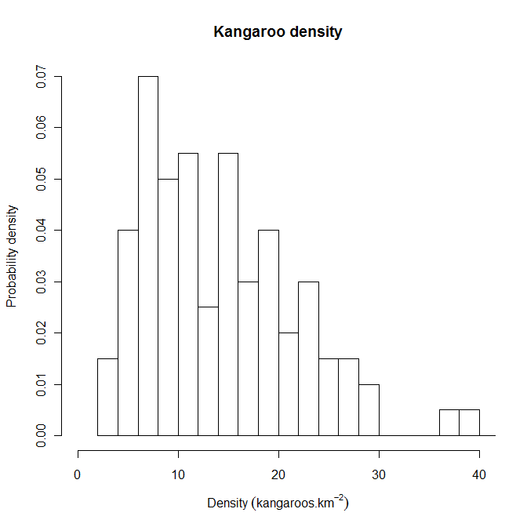
Figure 7: Histogram of a theoretical population of kangaroos.
Density is estimated by aerial survey and the frequency of estimated densities is converted to probability densities. The distribution of kangaroo densities is approximately lognormal.

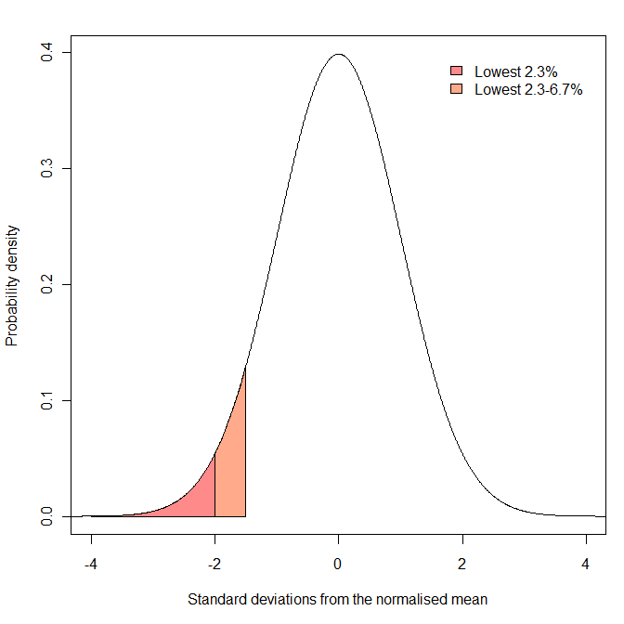
Figure 8: A theoretical distribution after z-score transformation.
The mean of the distribution is zero and the standard deviation is one. Areas under the distribution represent probabilities. The orange shaded region represents the probability that a sample is between 1.5 and two standard deviations below the mean (and represents 4.4 per cent of the area). The red shaded region represents the probability that a sample is more than two standard deviations below the mean (and represents 2.3 per cent of the area).

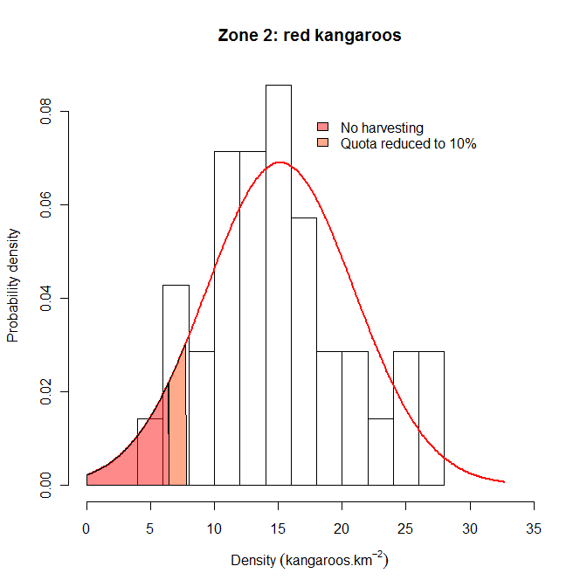
Figure 9: Example of setting harvest thresholds for red kangaroos in Zone 2.
The red line represents a normal probability distribution of the observed data with a mean of 15.2 kangaroos per square kilometre and a standard deviation of 5.8 kangaroos per square kilometre. The upper range of the orange region (7.8 kangaroos per square kilometre) represents the threshold within which harvest rate is reduced from 17 per cent to 10 percent. This lower rate is maintained unless density falls below 6.4 kangaroos per square kilometre, at which point harvesting ceases (red region). The thresholds were calculated after log transforming the data.
The following section shows how model simulations can be used to examine the relative effects of different thresholds applied to harvesting a theoretical population of red kangaroos.

Reducing the risk of overharvesting: an example using red kangaroos
The recommended strategy to minimise the risk of overharvest is to reduce harvest rate as density declines, with changes in harvest rate triggered at predetermined density thresholds. Appropriate thresholds can be considered by harvesting a simulated population of kangaroos (e.g. Milner-Gulland et al. 2001). An appropriate population model for red kangaroos was developed by Caughley (1987) and various forms of the model have continued to be used for assessing strategies for managing the kangaroo harvest (e.g. Hacker et al. 2004; Pople 2003, 2008).
Briefly, changes in kangaroo numbers are modelled as a function of pasture biomass which, in turn, is determined by recent rainfall, past pasture biomass and the density of kangaroos (and livestock) consuming the pasture. Harvesting obviously reduces kangaroo numbers, but the reduced density results in higher pasture biomass and therefore higher rates of increase of kangaroos. This improvement in environmental conditions for a population, which without harvesting has no long-term trend, is a basic requirement for the sustainability of a harvest. The population can be simulated 10,000 times over a 20 year period. Each run is different as, every three months, rainfall is drawn from a probability distribution using the average and standard deviation for rainfall in western NSW and thus reflects the uncertain food supply in this arid environment. Population size is also estimated with uncertainty by aerial surveys, and so this too was drawn from a probability distribution using the average and standard deviation associated with aerial surveys (Pople 2008). The population was harvested at an annual rate of 15 per cent or less if it was below a particular threshold.
Extinction is highly unlikely for this simulated population unless there is some combination of low numbers, catastrophic weather and unsustainable harvesting (i.e. much greater than 15 per cent). A more useful measure of threshold performance is the probability of the population dropping to a relatively low density. This can be calculated as the proportion of the 10,000 simulation runs where the population falls below particular densities. Thresholds can be expressed in terms of standard deviations (SDs) below long-term average density for a kangaroo management zone. That way, the aim of the threshold harvest strategy is to keep the harvested population above historically low density.
The effect of reducing harvest rate at varying SDs below the long-term average density for the simulated kangaroo population is shown in Figure 7. Reducing the threshold not surprisingly reduces the probability of very low density, but the decline in probability from no threshold (15 per cent harvest) to no harvest is smooth. There is therefore no obvious optimum with the choice being somewhat arbitrary. Notably, even an unharvested population has some chance of declining to very low density.

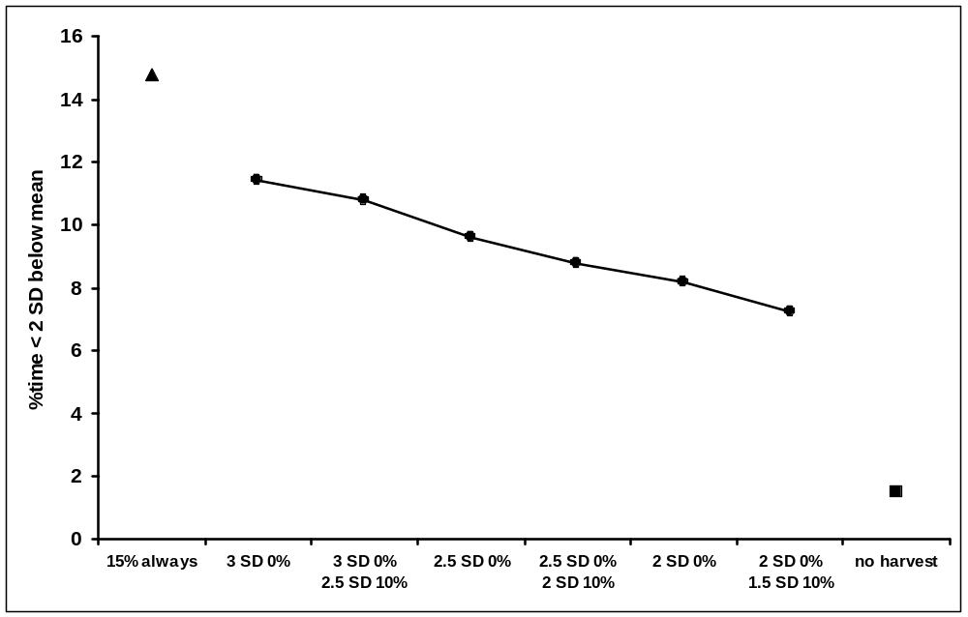
Figure 10: 10,000 simulations for a population fluctuating over 20 years.
Standard deviation (over time) was calculated from a lognormal distribution. Mean population size was about eight kangaroos per square kilometre. Density was about four kangaroos per square kilometre at two standard deviations below the mean.
Other factors that could be considered in setting thresholds is the time spent below some relatively low density (e.g. Figure 8), and the long-term average and variability in harvest offtake (including years with zero offtake) (Pople 2003). For these simulations, average harvest offtake was similar among the thresholds shown in Figures 7 and 8, but variability in the annual harvest increased slightly as the threshold was reduced.
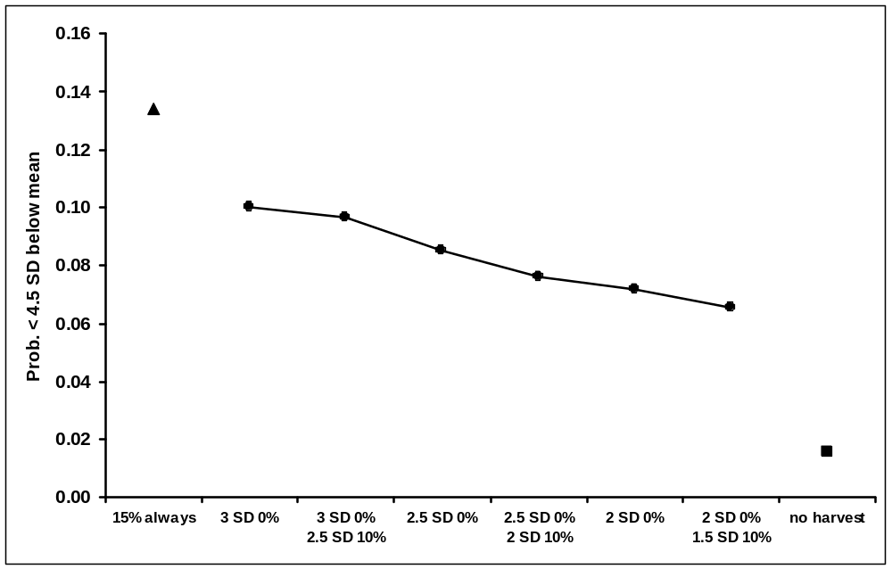
Figure 11. Simulated population as described for Figure 10.
Density was about two kangaroos per square kilometre at 4.5 standard deviations below the mean.

References
Caughley G (1987) Ecological relationships. In 'Kangaroos: their Ecology and Management in the Sheep Rangelands of Australia'. (Eds G Caughley, N Shepherd and J Short) pp. 159-187. (Cambridge University Press: Cambridge)
Deroba JJ & Bence JR (2008) A review of harvest policies: Understanding relative performance of control rules. Fisheries Research 94:210-223.
Engen S, Lande R & Saether B-E (1997) Harvesting strategies for fluctuationg populations based on uncertain population estimates. Journal of Theoretical Biology 186:201-212.
Hacker RB, McLeod SR, Druhan J, Tenhumberg B and Pradhan U (2004) 'Kangaroo management options in the Murray Darling Basin.' (Murray-Darling Basin Commission: Canberra).
Lande R, Engen S & Saether B-E (1995) Optimal harvesting of fluctuating populations with a risk of extinction. American Naturalist 145:728-745.
Lande R, Saether B-E & Engen S (1997) Threshold harvesting for sustainability of fluctuating resources. Ecology 78:1341-1350.
Milner-Gulland EJ, Shea K, Possingham H, Coulson T and Wilcox C (2001) Competing harvesting strategies in a simulated population under uncertainty. Animal Conservation 4: 157-167.
Pople A (2003) 'Harvest management of kangaroos during drought.' Unpublished report to New South Wales National Parks and Wildlife Service, Dubbo, NSW.
Pople AR (2008) Frequency and precision of aerial surveys for kangaroo management. Wildlife Research 35: 340-348.
Pople AR & Grigg G (1999) Commercial harvesting of kangaroos in Australia. At www.environment.gov.au/biodiversity/trade-use/wild-harvest/kangaroo/harvesting/index.html

