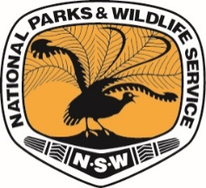
NSW National Parks and Wildlife Service

Post-event report
Event details
Event name
Event date/s
Weather conditions

Final numbers
Total number of participants  (please attach ticket report) |  | Total spectators:  Total crew:

Incidents
Please describe any incidents that occurred on NPWS land, or attach a copy of the incident report form. |  | Was an incident report form completed?  □ Yes □ No  Has it been provided to NPWS?  □ Yes □ No

Damage
Please describe any damage to NPWS land or facilities and how it occurred. If any photos were taken, please attach.

Operational summary
Please provide an operational summary, including the following:
- venue suitability
- signage and markings
- interaction with other park users
- transport/access
- waste/rubbish management
Key recommendations
Please provide key recommendations for future events.
Date planned for next event (if any).
New application must be submitted to hold dates.
Customer experience
How would you rate your experience in holding your event with NPWS? | Pre event: | 5 – Very good  4 – Good  3 – Satisfactory  2 – Disappointing  1 – Very disappointing
 | On site:
Do you have any suggestions on how we can improve the experience?


Environment and Heritage.
Department of Climate Change, Energy, the Environment and Water
Locked Bag 5022, Parramatta NSW 2124; Phone: 1300 361 967
Email: info@environment.nsw.gov.au; www.environment.nsw.gov.au
ISBN 978-1-923516-17-5; EH 2025/0219; September 2025

